RUNNING HEAD: Terrorist Images, Counterterrorism action preferences, Authoritarianism, Social Dominance Orientation

TERRORIST IMAGES AND COUNTERTERRORIST ACTION PREFERENCE: THE MODERATING ROLE OF AUTHORITARIANISM AND SOCIAL DOMINANCE ORIENTATION

Abstract
Two studies examine the moderating effects of authoritarianism and social dominance orientation on the relationship between terrorist images (as enemy soldiers vs criminals) and preference for counterterrorist actions (military aggression vs prosecution by the international justice system). The results of a correlational study conducted in Poland indicate that the perception of Al-Qaeda terrorists as soldiers is related to preference for military aggression especially among people high in social dominance orientation, whereas the perception of Al-Qaeda terrorists as criminals is related to preference for the criminal justice system actions especially among authoritarians. People high in social dominance orientation who do not perceive the terrorists as soldiers oppose the military response to terrorist threat. The results of an experimental study conducted in Great Britain replicate these findings showing that, when Al-Qaeda terrorists are framed as soldiers, people high in social dominance orientation support aggressive counterterrorist actions but when the terrorists are framed as criminals, they oppose both aggression and criminal justice system actions. When the terrorists are framed as criminals, authoritarians support international police cooperation to haunt and prosecute terrorists. Together the studies suggest that different terrorist images (chronic or framed) lead to preference for counterterrorist actions relevant to their content but only among people to whose ideological orientations and broader worldviews these images correspond.

Key words: Terrorists Images, Counterterrorism Action Preferences, Right Wing Authoritarianism, Social Dominance Orientation

The issue of the most effective and appropriate counterterrorist measures is brought to public awareness with every major terrorist attack. What counterterrorist policies are finally preferred and chosen seems to be, at least to some extent, shaped by the dominating ideological ‘climate’ (e.g. the emphasis on conservative vs. liberal political values, e.g. Farer, 2008) and the way terrorism is framed by the media and politicians (e.g. Norris, Kern & Just, 2003). Recent psychological analyses suggest that different perceptions of terrorists and terrorism are associated with different understanding of the goals of counterterrorism and preference for different counterterrorist actions (e.g. Kruglanski, Crenshaw, Post & Victoroff, 2007). Importantly, it has been proposed that framing terrorists as soldiers or criminals and terrorism as an act of war or a crime may have different consequences for desired counterterrorist actions and broader intergroup relations (McCauley, 2007). We argue that these specific terrorist frames may have a different appeal to people who differ with respect to the ideological orientations that color their perception of human nature and intergroup relations.
Social dominance orientation (Pratto, Sidanius, Stallworth, & Malle, 1994; Sidanius & Pratto, 1999 ) and authoritarianism (e.g. Altemeyer, 1996), grounded in distinct basic worldviews and values (Duckitt, 2006; see also Cohrs, Kielmann, Maes, Moschner, 2005b), predispose people to pay attention to and become incited to form a preference for counterterrorist actions by different terrorists images. As a consequence, people high in social dominance orientation and authoritarians are likely to differ with respect to preference for war vs. international cooperation among criminal justice systems as counterterrorism measures. This difference may become especially pronounced when they chronically perceive or are prompted to perceive terrorists as enemy soldiers or criminals. We test these propositions in two empirical studies conducted in two European countries. Before we outline our hypotheses in more detail, we discuss the role of terrorist perception and ideological orientations in shaping responses to terrorist threat.
Terrorist images and preference for counter-terrorist actions
Since the terrorists attacks of 9/11 made terrorism a very salient topic of the scientific analysis, a lot has been said about the psychology of individual terrorists and terrorist organizations (e.g. Crenshaw, 1998; Kruglanski, Chen & Golec de Zavala, 2008; Kruglanski, Chen, Dechesne, Fishman & Orehek, 2008; Kruglanski & Fishman, 2006; McCauley, 2006; F. Moghadam, 2005; A. Moghadam, 2003; Pape, 2005). Most authors see terrorism as a rational strategy for attaining organizational goals (e.g. Cernshaw,1998; F. Moghadam, 2005). However, bias and the irrational aspect of terrorist thinking are also emphasized (Spirznak, 2001). Importantly, it has been suggested that individual and group-based reactions to terrorist threats may be shaped and influenced by the way terrorists are framed and perceived (Kruglanski et al, 2007; McCauley, 2007; Pronin, Kennedy & Butsch, 2006).
Kruglanski et al (2007), for example, propose that different interpretations of the acts of terrorism are associated with different ways of understanding of the nature of counterterrorism. Understanding counterterrorism as a search for a cure for the indoctrinated follows the perception of terrorism as a disease. Treating terrorism as a strategy of action in an escalated inter-group conflict motivates the search for the most adequate and rational conflict resolution strategy. Counterterrorism seen as an ingroup’s involvement in a fight with a dangerous enemy is related to understanding terrorist attacks as an act of war, whereas perceiving terrorists primarily as criminals is likely to increase efforts to capture and prosecute individual perpetrators of the unlawful acts in order to punish and isolate them. In a similar vein, Pronin et al (2006) empirically demonstrate that portraying terrorists as irrational fanatics elicits preference for unilateral aggression as a way of dealing with terrorism. On the other hand, when terrorists are portrayed as rational strategists, even though they are still seen as killers, diplomatic ways and negotiations are considered as possible counterterrorist responses.
McCauley (2007) argues that, most typically, terrorist attacks are framed by the media and politicians as acts of war or a crime. Importantly, these frames elicit different emotional responses and encourage different counterterrorism actions. When terrorism is framed as a strategy of warfare, it is likely that terrorists will be seen as warriors, the soldiers of the enemy. Thus, they will be seen as homogenous and interchangeable representatives of an outgroup that threatens the well-being if not mere existence of the ingroup. Within this perspective the members of the ingroup are likely to be perceived as similarly interchangeable actors motivated by the single purpose of defending the ingroup. On the other hand, framing terrorism as a crime does not mobilize the group-based response. Within this perspective terrorists are likely to be seen as individual criminals, lawbreakers or social deviants.
The different assumptions about who the terrorist actors are (a group vs an individual) elicit different propositions concerning the most adequate counterterrorist measures. War is an adequate response when terrorists are portrayed as enemy soldiers, whereas the efforts of the police and the system of justice to capture, prosecute and punish are appropriate responses to the framing of terrorists as criminals. These actions differ in target (groups vs. individuals) and scope (short-term mobilization of resources to fight the war until it is won vs. long-term police-like strategies of international cooperation and building knowledge bases of the criminal contexts and activities). Framing terrorism as an act of war requires a group-level response in which the lives of individuals are dispensable. It also elicits actions that are likely to intensify intergroup tensions and escalate the intergroup conflict. Framing terrorism as a crime results in more precise targeting of those against whom the counterterrorist actions are directed. The lawful punishing of individual terrorists is less likely to significantly radicalize the so-far-halfhearted supporters of the terrorist cause and mobilize the group-based response that terrorist organizations usually hope for (e.g. McCauley, 2004).
In the present paper we attempt to empirically verify these theoretical propositions. More specifically, we aim to examine whether there is a relationship between the perception and framing of terrorists as soldiers and preference for aggressive counterterrorist actions and the relationship between the perception and framing of terrorists as criminals and support for criminal justice system counterterrorist actions. However, we also propose that these relationships may be not as straightforward as initially suggested. We hypothesize that individual ideological orientations related to different assumptions about the nature of social world are likely to moderate these relationships.

Ideological orientations, terrorist images and preferred counterterrorist strategies
We propose that people may be prompted to (or at least form a preference for) counterterrorist actions by different terrorist images because certain terrorist perceptions fit their broader worldviews and counterterrorist actions that are relevant to these perceptions meet their psychological needs. In addition, people may draw different conclusions from the same terrorist images. Thus, individual ideological orientations may moderate the relationship between terrorist images and the choice of counterterrorist actions because people high in social dominance orientation and authoritarians may find different terrorist images particularly threatening and prefer different protective counterterrorist actions when these images are salient. Empirical studies confirm that authoritarianism and social dominance orientation, although positively related (Cohrs et al, 2005b; Duriez, Van Hiel & Kossowska, 2005; Pratto et al, 1994; Roccato & Ricolfi, 2005; Sidanius & Pratto, 1999; Whitley, 1999) and often predictive of similar social attitudes and behaviors, are grounded in different worldviews and place importance on different aspects of social relationships.
Social dominance orientation is defined as a desire for hierarchical social order and unequal relations among social groups (Sidanius & Pratto, 1999). People high in this orientation strive to belong to more dominant groups, suffer if they do not and support social beliefs that legitimize and maintain existing social inequalities (Jost & Thompson, 2000; Pratto et al., 1994; Sidanius, Pratto, & Rabinowitz, 1994; Sidanius, et al., 2001). Authoritarianism is typically defined as the convergence of (1) submissiveness to the established social authorities; (2) adherence to the social conventions endorsed by society at large and the social authorities and (2) aggressiveness towards those who question or endanger social conventions and those who are indicated by the established authorities (Altemeyer, 1988, 1996). Both variables reliably predict prejudice (e.g. van Hiel & Marvielde, 2002) and aggressiveness in inter-group relations, (e.g. Adorno, et al, 1950; Altemeyer, 1998; Sidanius & Pratto, 1999). However, they predict different kind of prejudice (Cohrs et al, 2005b; Duriez & van Hiel, 2002; Duckitt, 2006; Kreindler, 2005) and their inter-group effects are independent (Duckitt et al, 2002; McFarland, 2005); their effects are additive, rather than interactive (Sibley, Robertson & Wilson, 2006). Importantly, authoritarianism and social dominance orientation seem to develop from different motivational goals and are associated with different worldviews (Duckitt, 1989, 2006; Duckitt & Fisher, 2003; Duckitt & Sibley, 2006; Duckitt, et al, 2002). They are also related to different emotions (e.g. Van Hiel & Kossowska, 2006; Kossowska, Bukowski & van Hiel, 2008); personality traits (e.g. Ekehammar, et al, 2004; Heaven & Bucci, 2001), and values (Cohrs, Kielmann, Maes, Moschner, 2005c; Duriez & van Hiel, 2002; Rohan & Zanna, 1996).
More specifically, authoritarian goals pertain to control and security in a world seen as a dangerous place. Authoritarians are concerned with group cohesion, social order and stability that maintain group security and the predictability of the social environment (e.g. Duckitt, et al, 2002, 2006). Authoritarian aggression is directed towards those who threaten an in-group, its authorities and the epistemic security they provide (see Kruglanski et al., 2006). Authoritarians are aggressive when they think it is necessary to defend the in-group and when they think such behavior is moral (justified by the authorities) (see Kreindler, 2005). People high in social dominance orientation, in contrast to authoritarians, are motivated by goals of dominance, superiority and power. They view the social world as a competitive jungle and group relations as a result of struggle for dominance. They strive to establish and/or maintain group-based dominance. Their hostility is directed towards groups that arouse their competitiveness over status or power (e.g. Duckitt, et al, 2002; Duckitt, 2006). People high in social dominance orientation fight because they think they will be attacked, fight to win because otherwise they will lose, to dominate because otherwise they will be dominated.

Assumptions tested in the present studies
In the studies presented in this paper, we test the hypothesis that the perception of terrorists as criminals vs. soldiers of the enemy will be related to choice of different strategies of counterterrorism. More specifically, we assume that chronic or prompted perceptions of terrorists as criminals will be related to preference for police and criminal justice system actions, whereas the perception of terrorists as enemy soldiers will be related to preference for aggressive intergroup actions. Importantly, we assume that these relationships will be only or especially pronounced among authoritarians or people high in social dominance orientation, respectively.
In other words, we predict that when the salient (chronic or situationally manipulated) image of terrorists is the one of criminals, authoritarians, but not necessarily people high in social dominance orientation, will be likely to prefer police actions and the prosecution of suspected terrorists. It can be expected that authoritarians will be particularly threatened and motivated to (or at least form a preference for) counterterrorist actions when they perceive or are prompted to perceive terrorists as criminals, i.e. unpredictable, dangerous social deviants that threaten social order and security. It can be expected that the counterterrorist actions that authoritarians may prefer in such a context will focus on regaining and maintaining internal security and control. Thus, authoritarians perceiving terrorists as criminals are likely to support ‘restoring’ and ‘ordering’ actions such as the police pursuit of perpetrators of terrorist acts and the prosecution of terrorist suspects. Supporting these predictions, previous studies indicate that authoritarians prefer counterterrorist actions that have to do with increasing internal control and surveillance even if they need to sacrifice their personal freedoms (e.g. Cohrs, Moschner, Maes & Kielmann, 2005a; Cohrs, et al, 2005b; Crowson et al., 2006). In addition, authoritarians, but not people high in social dominance orientation, prefer to remove ‘suspicious’ people (e.g. immigrants from countries supporting terrorism) from their country in order to reduce the terrorist threat (Skitka, Bauman, Aramovich & Morgan, 2006). However, to our knowledge no earlier studies examined the role of authoritarianism in support for cooperation among international justice systems in order to capture and prosecute terrorists, especially in response to framing (or chronically perceiving) terrorist as criminals (see Pronin et al., 2006).
In addition we predict that when the salient (chronic or situationally manipulated) image of terrorists is one of enemy soldiers, especially people high in social dominance orientation, but not authoritarians, are likely to choose belligerent and coercive counterterrorist actions. It can be expected that people high in social dominance orientation will be more likely to become mobilized by the perception of terrorists as enemy soldiers rather than criminals. They are also likely to prefer counterterrorist actions that correspond to this image, i.e. coercion and aggression to police and justice system actions. Since their social world is based on such categories as force, influence, power and competition, people high in social dominance orientation are likely to become motivated to action (or at least to form a preference for counterterrorist actions) by terrorists to whom they attribute characteristics typical for rivals in a struggle over power and dominance. In response, they are likely to support coercive actions against terrorists in the power struggle in which the prevalence of the ingroup is the main concern. In this vein, previous studies confirm that support for coercive counterterrorist actions among people high in social dominance orientation is associated with decreased concern for the human cost of war (McFarland et al., 2005).
We test our hypotheses in a correlational study conducted in Poland (Study 1) and an experimental study conducted in Great Britain (Study 2). In study 1 we assess individual ideological orientations and chronic tendencies to perceive Al-Qaeda terrorists as soldiers or criminals. In study 2 we assess individual ideological orientations and manipulate the way the terrorist is framed. In both studies we examine the role of terrorist images and individual orientations in shaping preferences for counterterrorist responses.

Study 1
Study 1 examined the relationships between the terrorist images people hold and their preferences for different counterterrorist actions: military aggression vs. cooperation among international police forces and criminal justice systems to capture and prosecute terrorists. Most importantly, the study looked at how these relationships are moderated by individual levels of authoritarianism and social dominance orientation. The study controlled the role of political conservatism, a variable typically associated with preference for coercive responses to intergroup threat (e.g. Holsti, 1990). We used a newly constructed scale to assess perception of Al-Qaeda terrorists.

Method

Participants and procedure.
The first study was conducted among 298 Polish undergraduate students of whom 176 were females and 122 males. The mean age of participants was 24.36 (SD = 2.25). Participants were asked to complete a questionnaire containing several psychological measures in return for research participation credit.
Measures
Social dominance orientation. An abbreviated 10-item version of the Social Dominance Scale (Sidanius & Pratto, 1999; see also McFraland, 2005) was used (α = .87; M = 3.01; SD = 1.08).
Right Wing Authoritarianism. The abbreviated 10-item version of the original RWA Scale proposed by Altemeyer (1988; see also McFarland, 2005) was used (α = .77; M = 3.75; SD = .90).
Political conservatism. This variable was measured by one question: “Please describe your political outlook using the following scale:” and the scale from “1” = “very liberal” to “5” = “very conservative” (M = 3.87; SD = .98).
Al-Qaeda Terrorist Image. The perceptions of Al-Qaeda terrorists as soldiers or as criminals were assessed by means of the newly constructed Terrorist Image Scale (Kubik & Kossowska, 2007). In this scale participants are asked to assess the probability that a typical Al-Qaeda terrorist possesses each of the 26 characteristics. They Participants respond using a scale ranging from 0% to 100%.
The scale was constructed in order to uncover people’s ‘private theories’ of who the terrorists are and what they are like. The adjectives used to describe the Al-Qaeda terrorist emerged from content-analytic validation studies (Kubik & Kossowska, 2007; Kossowska, Golec de Zavala & Kubik, in press). First, a diverse group of participants was interviewed about their perceptions of Al-Qaeda terrorists. The interviews were content-analyzed by 3 independent judges who classified the obtained terrorist descriptions into broader categories. A list of 31 adjectives and phrases used to characterize the terrorists was obtained and administered to a large group of participants in Poland (and a number of other countries, Kossowska, Trejtowicz, de Lemus, Van Hiel & Goodwin, 2008), asking them to assess the probability that Al-Qaeda terrorist possess each of these characteristics. Factor analyses examined the structure of cognitive representations of Al Qaeda terrorists. In Poland, these analyses reliably reveal a four-factorial structure with orthogonal factors: ideologues (men of cause motivated by their beliefs), soldiers of the enemy (using terrorist actions as method of warfare), criminals (inhumane and blood thirsty) and victims of the system (forced to unwanted violence by experienced oppression). Studies in other countries differ, usually revealing two-factorial structure captured images of terrorists as soldiers of the enemy and as criminals (Kossowska et al., 2008).
In the present study we were interested in two terrorist images in particular: soldiers of the enemy and criminals. The scale assessing the image of terrorists as soldiers contains adjectives and phrases emphasizing the political goals of terrorists (organized, power hungry, focused on a political goal) and carefully chosen methods to achieve them (armed, publicity seeking, dreadful) (α = .79; M=77; SD=12.01). The scale assessing the image of terrorists as criminals contains adjectives and phrases that stress the egocentric goals and cynical methods of individual terrorists. The traits ascribed to terrorists seen as criminals suggest emotional blindness and lack of human feelings: e.g. criminal, egocentric, inhumane, aggressive, and mindless (α = .69; M=80; SD=17.7).
Support for coercive counterterrorist actions. This variable was measured with 5 items adopted from the scale proposed by Pronin and colleagues (2006). Participants were asked whether they agreed that each of following was a good and effective strategy of dealing with terrorism: Air strikes against terrorist weapons and supply storage; Entering war with countries that support terrorism; Military actions in response to any terrorist attack; Attacks by ground troops against terrorist strongholds and Assassination of terrorist leaders responsible for terrorist attacks (α = .79; M = 2.92; SD = .62). Participants indicated their opinions on a scale ranging from “1” = “totally disagree” to “6” = “totally agree”.
Support for international cooperation among police forces and criminal justice systems. This variable was measured with 4 items adopted from the scale proposed by Pronin and colleagues (2006): ‘International cooperation among police forces on tracking terrorist organizations and their networks’;’ International cooperation among police forces in hunting down terrorist leaders’ and ‘International cooperation among criminal courts in fast and tough sentencing of captured terrorism’ (α = .90; M = 3.729; SD = 0.59). Participants indicated their opinions on a scale ranging from “1” = “totally disagree” to “6” = “totally agree”.
Results
The initial correlational analyses (Table 1) indicate that a tendency to perceive Al-Qaeda terrorists as enemy soldiers is positively associated with a preference for military action as a counterterrorist response. It is also weakly and positively associated with social dominance orientation but not authoritarianism. A tendency to perceive Al-Qaeda terrorists as criminals is positively associated with a preference for criminal justice actions in response to terrorism and right wing authoritarianism and negatively related to social dominance orientation. The two images of Al-Qaeda terrorists are not significantly related. Political conservatism correlates positively with all measured variables.
INSERT TABLE 1
Terrorist perceptions, ideological orientations and preferred counterterrorist actions
In order to test the hypothesis that war and police actions as desirable counter terrorism measures can be predicted from different perceptions of Al-Qaeda terrorists in interaction with different ideological orientations we conducted a series of 2 hierarchical multiple regression analyses. The same model was first tested using support for coercive, military responses to terrorism as the criterion variable. Next support for police and criminal justice systems cooperation was used as the criterion variable. The perceptions of Al-Qaeda terrorists as soldiers of the enemy and as criminals, authoritarianism and social dominance orientation were entered to the regression equation in step 1 and the hypothesized interaction of authoritarianism and perception of terrorists as criminals and social domination orientation and perception of terrorists as soldiers were entered in step 2 in order to assess whether adding the interaction terms significantly increases the amount of variance explained in the criterion variable. The analyses controlled for the participants’ age, gender and self-defined political conservatism. Since earlier studies and present correlation analyses indicate that conservatism is related to authoritarianism, social dominance orientation and coercive intergroup actions, its possible effect should be covaried out. We followed the procedure proposed by Aiken & West (1991) while conducting the hierarchical multiple regression analysis. All variables were centred prior to analysis.
The results of the regression analysis that used the support for coercive counterterrorist actions as the criterion variable revealed significant, positive, first order effects of social dominance orientation (b = .22; SE =.05 ; β =.23; p <.001) and the perception of Al-Qaeda terrorists as soldiers (b = .19; SE = .06 ; β = .19; p <.01). These effects were qualified by a significant interaction of social dominance orientation and the perception of terrorists as enemy soldiers (b = .14; SE =.07 ; β =.15 ; p <.05). Adding the interaction terms to the equation significantly increased the amount of explained variance (ΔR²(2, 297) =.02; p < .05). (see: Table 2).
INSERT TABLE 2
This interaction was probed using the procedure proposed by Aiken & West (1991). The results indicate that social dominance orientation was positively and significantly related to support for military counterterrorist actions among those participants who perceived terrorists as enemy soldiers (one standard deviation above the mean of the scale measuring the perception of Al-Qaeda terrorists as enemy soldiers) (b =.27; SE =.05; β= .25; p< .01). Social dominance orientation was negatively and significantly related to support for military counterterrorist actions among participants who did not perceive Al-Qaeda terrorists as soldiers (one standard deviation below the mean of the scale measuring the perception of Al-Qaeda terrorists as enemy soldiers) (b =-.25; SE =.07; β= -.19; p<.05) (Figure 1).
INSERT FIGURE 1
The results of the multiple regression analysis using the support for cooperation among international police forces and criminal justice systems as the criterion variable revealed significant, positive, first order effects of authoritarianism (b = .23; SE =.06 ; β =.23; p < .001) and perception of Al-Qaeda terrorists as criminals (b = .25; SE = .05; β =.25; p < .001). These effects were qualified by a significant interaction of authoritarianism and the perception of terrorists as criminals (b =.18; SE =.05 ; β =.15 ; p <.01 ). Adding the interaction terms to the equation significantly increased the amount of explained variance (ΔR²(2, 297) = .02; p < .01) (see: Table 3).
INSERT TABLE 3
The probing of this interaction indicated that authoritarianism was positively related to support for international police cooperation among those participants who perceived terrorists as criminals (b =.23; SE =.07;β=.21; p<.001) and it was negatively related to support for international police cooperation among participants who did not perceive terrorists as criminals (b =-.19; SE =.08;β= -.15; p= .056). This slope was marginally significant (Figure 2).
INSERT FIGURE 2
Discussion of Study 1
The results of study 1 revealed expected pattern of results. They indicate that different perceptions of Al-Qaeda terrorists are related to a preference for different counterterrorist actions. These counterterrorist actions are relevant and adequate to the particular contents of the terrorist images. People who see terrorists as enemy soldiers, a group of devoted warriors pursuing political goals that threaten the well-being but also the prestige of the in-group, tend to support coercive and warlike counterterrorism. People who see terrorists predominantly as bloodthirsty criminals threatening important values and social order choose to delegate the responsibility for counterterrorist actions to forces indicated for the chase, capture and prosecution of criminals – the police and criminal justice system. In addition, as predicted, authoritarians concerned with security and social order tend to prefer police cooperation and prosecutions of terrorists, whereas people high on social dominance orientation concerned with competition for status tend to prefer military counterterrorist responses.
Importantly, as expected, the relationships between terrorist perceptions and relevant counterterrorist actions are moderated by individual ideological orientations. The support for coercive counterterrorism is strongest among people high in social dominance orientation who view terrorists as soldiers and enemies of the in-group. Interestingly, people high in social dominance orientation who do not perceive Al-Qaeda terrorists as enemy soldiers oppose the use of coercive counterterrorism. The support for police actions is strongest among authoritarians who see Al-Qaeda terrorists as criminals. Notably, according to expectations, social dominance orientation, but not authoritarianism interacted with perception of terrorists as soldiers in predicting support for war on terrorism, whereas authoritarianism but not social dominance orientation interacted with the perception of terrorists as criminals in predicting support for the criminal justice system in dealing with the terrorist threat. These results suggest that authoritarians and people high in social dominance orientation are sensitive to different aspects of the terrorist threat and different terrorist images motivate them to respond.
The results of study 1, however supportive and promising, leave several issues unresolved. The correlational design of study 1 does not allow us to make a firm conclusion about the direction of causality in the hypothesized relationships. We assumed that the terrorist images would lead to a preference for relevant counterterrorist actions. This assumption is based on numerous studies that suggest that basic perceptions and broader ideological orientations constrain specific attitudes, such as support for actions in an intergroup context (rather than vice versa; e.g. Cohrs, et al, 2005b; Duckitt, 2006; Duckitt & Sibley, 2006; Feshbach, 1994; de Figueiredo & Elkins, 2003; Sidanius, Feschbach, Levin & Pratto, 1997). However, it is possible to imagine that the terrorist perceptions might serve as justification for preferred counterterrorist strategies that are for example related to individual ideological orientations. The negative relationship between social dominance orientation and a preference for military counterterrorist actions when terrorists are not perceived as soldiers and marginally significant and negative association between authoritarianism and preference for criminal justice system actions already speak against this possibility. However, in order to be able to convincingly demonstrate that people high in authoritarianism and high in social dominance react differently to different terrorist images, we conducted a second experimental study. Study 2 attempts to provide evidence that authoritarians and people high in social dominance orientation selectively find different terrorist frames appealing, inspiring their choices of counterterrorist actions.
Study 2
Study 2 aimed to replicate the results of Study 1 in an experimental design. It investigated the influence of framing the perception of Al-Qaeda terrorists as soldiers or criminals on the preference for counterterrorist actions (military actions vs. police and criminal justice system actions). Moreover, study 2 examined whether this influence is moderated by individual levels of social dominance orientation and right wing authoritarianism. It was hypothesized that when Al-Qaeda terrorists are framed as enemy soldiers, the participants would be more likely to prefer coercive counterterrorist actions than when terrorists are framed as criminals, especially when they are high in social dominance orientation. It was also expected that when Al-Qaeda terrorists are framed as criminals (rather than when they are framed as soldiers) the preferred counterterrorism strategies would more likely be those of control, and detainment. This effect was assumed to be stronger among authoritarians. Similarly as in study 1, in study 2 we controlled political conservatism in order to covary out its possible relationship with preference for coercive intergroup actions as well as its often reported relationship with authoritarianism and social dominance orientation.

Participants
The study was conducted among 220 British undergraduate students who took part in the study in exchange for research participation credit. Their age ranged from 17 to 52 (M = 24.15; SD = 6.37). There were 152 women and 68 men. One hundred and twelve participants defined their religion as Christian; 21 identified themselves as Muslim; 40 described themselves as non-religious; 7 as Hindu; 3 as Buddhists and 3 as Jewish. One hundred participants defined their ethnicity as White; 67 as Black; 25 as Arab; 20 as Asian and 10 participants did not provide data about their ethnicity.
The data obtained from participants who identified their religion as Islam or their ethnicity as Arab were removed from further analyses (n = 27). Since the study was designed around the London Bombings of 7th of July 2005 perpetrated by Arab Muslims, we assumed that the religious identity of our Muslim participants might influence their responses regarding measures against Islamic terrorist organizations. The analyses were performed on the reduced sample of 193 participants aging from 17 to 52 (M = 24.25; SD = 6.44) of whom 133 female and 60 male.

Procedure
Participants were asked to take part in a study on opinions about the terrorist threat and counterterrorism policy in Britain. They were handed booklets containing several psychological measures. The booklet contained demographic questions and the Conservative-Liberal Self-Placement Scale, Social Dominance Orientation (Pratto et al, 1994) and Right Wing Authoritarianism Scales (Altemeyer, 1996), an introduction to the topic of the terrorist threat and counterterrorism strategies that contained the experimental manipulation and a questionnaire measuring the preference for counterterrorist actions (Pronin et al, 2006). Ninety five participants were asked to respond to an additional measure checking the effectiveness of the experimental manipulation. The manipulation check analyses were performed on a sample of 77 participants after the data obtained from Muslim participants were removed.

Experimental manipulation
In order to frame Al Qaeda terrorists as soldiers or criminals, we used a fragment of a mock newspaper article that contained an alleged speech by then Mayor of London, Ken Livingstone, after the terrorist attacks in London in 2005. All participants first read the introduction: “Terrorism is a grave problem that we experience nowadays. In this study we would like to ask about your opinions about counter terrorism policies in Britain. Before we ask about your opinions please read a summary of what the Mayor of London said about the 7th of July London bombings”
Al Qaeda terrorists were then framed as criminals (n = 99) or as enemy soldiers (n = 94).

In the criminals conditions the participants were asked to read the following fragment of the alleged speech:
“Terrorist bombing is an indiscriminate attempt at mass murder. Terrorists are organized criminals, deviants from their own society. It is not just an attempt to slaughter people, irrespective of any considerations for age, for class, for religion, or whatever. It is an attack of the social order of free, inclusive and civil society. It is an attack that is intended to divide us and undermine our political and legal system. We will stand side by side and protect our society from terrorist disruptions.”

Al Qaeda terrorists as soldiers was framed by the following fragment:
“Terrorist bombing is an unprovoked act of war. Terrorists are the soldiers of the enemy fighting for the goals of their group. It is not just an attempt to slaughter people, irrespective of any considerations for age, for class, for religion, or whatever. It is not just an attack on a city or a country. It is an attack of the idea of free, inclusive and civil society. It is an attack that is intended to break the spirit. In this war we are right and they are wrong. We will achieve unconditional victory over terrorism and terrorists.”

Measures
The same measures of social dominance orientation (α = .74; M = 2.76; SD = .88); right wing authoritarianism (α = .62; M = 3.52; SD = .76) and political conservatism (M = 2.62; SD = .83) as in Study 1 were used. The dependent variables were also assessed using identical measures as in study 1. Participants indicated their support for coercive counterterrorist actions (α = .79; M = 3.28; SD = 1.13) and for cooperation among international police forces in capturing and prosecuting terrorists (α = .90; M = 4.69; SD = 1.24).
Two manipulation check measures were included.
Perception of terrorists as soldiers. This variable was measured by 3 items: “Terrorists are soldiers”;” Terrorists are devoted to their group”; and “Terrorists are fighters for the cause” (α = .53; M = 4.13; SD = 1.12). Participants were asked to provide their answers on a scale ranging from “1” = “totally disagree” to “6” = “totally agree”.
Perception of terrorists as criminals. This perception was assessed 2 items: “Each and every terrorist is a criminal” and “Terrorists are cold-blooded and cunning” (α = .67; M = 4.19; SD = 1.18). Participants were asked to provide their answers on a scale ranging from “1” = “totally disagree” to “6” = “totally agree”.
Results
Perception of terrorists after framing the terrorists as soldiers vs criminals
The inspection of mean responses to the questions measuring the perception of terrorists as enemy soldiers revealed that participants scored significantly higher on this measure in the research conditions in which the terrorists were framed as soldiers (M = 4.52; SD = 1.25) than in the research conditions in which the terrorists were framed as criminals (M = 3.95; SD = 1.29; F (1,76) = 4.40; p <.04; η² = .06). Similarly, in the research conditions in which Al-Qaeda terrorists were framed as criminals participants agreed more with the statements describing terrorists as criminals (M = 4.45; SD = 1.22) than in the research conditions in which the terrorists were framed as enemy soldiers (M = 3.95; SD = 1.11; F (1,75) = 3.48; p <.05; η² = .04). These analyses speak to the effectiveness of the experimental manipulation in framing the terrorists either as soldiers of the enemy or as criminals.
Correlational analyses revealed that across the research conditions only political conservatism was significantly associated with preference for coercive counterterrorism actions (r (192) = . 31; p < .001). Political conservatism was included in further analyses as a control variable.

Framing the terrorists, ideological orientations and preferred counterterrorist actions
In order to test the hypothesis that framing Al-Qaeda terrorists as soldiers will result in the choice of coercive and war-like counterterrorism responses, especially among people high in social dominance orientation, and the hypothesis that framing terrorists as criminals will result in preference for police and criminal justice system actions, especially among authoritarians, we conducted a series of 2 hierarchical multiple regression analyses following the procedure proposed by Cohen et al. (2003).
All variables were centred prior to analysis. Research conditions (dummy coded 0 –criminal/1 - soldier), authoritarianism and social dominance orientation were entered to the regression equation in step 1. Two interaction terms - authoritarianism x research conditions and social dominance x research conditions were entered in step 2 in order to assess whether adding the interaction terms significantly increases the amount of variance explained in the criterion variables. The analyses controlled for age, gender and political conservatism.
The results of the regression analysis that looked at support for coercive counterterrorist actions as the criterion variable revealed significant, positive first order effects of age (b = -.04; SE = .01; β = -.25; p < .001) and political conservatism (b = .39; SE = .08; β = .35; p < .001) and a significant interaction effect between social dominance orientation and research conditions (b = .27; SE = .04; β = .24; p < .001). Adding the interaction terms to the regression equation significantly increased the explained variance (Δ R² (2,176) = .05; p < .005) (see: Table 4).
INSERT TABLE 4
In order to further analyze the interaction we computed the simple slopes for the conditions in which Al-Qaeda terrorists were framed as criminals and for the conditions in which Al-Qaeda terrorists were framed as soldiers according to the procedure proposed by Cohen et al. (2003). The results indicate that, when the terrorists were framed as enemy soldiers, people high in social dominance orientation supported the coercive counterterrorism actions strategies (b = .27; SE = .12; β = .15; p < .02) but they rejected them when the terrorists were framed as criminals (b =-.26; SE = .11; β = -.18; p < .01) (Figure 3).
INSERT FIGURE 3
The results of the analysis that examined support for cooperation among international police forces and systems of justice as the criterion variable revealed a marginally significant, positive, single order effect of authoritarianism (b = .17; SE = .10; β = .13; p = .10), while the second step revealed a significant interaction between authoritarianism and research conditions (b = -.18; SE = .11; β = -.15; p < .05) and a significant interaction between social dominance orientation and research conditions (b = .28; SE = .10; β = .23; p < .01). Adding both interaction terms to the regression equation significantly increased the explained variance (Δ R² (2,176) = .045; p < .02) (Table 5).
INSERT TABLE 5
The results of simple slopes analyses probing the interactions showed that only when Al-Qaeda terrorists were framed as criminals authoritarians supported criminal justice system actions to prosecute the suspected terrorists (b =.32; SE = .14; β = .23; p < .02). When Al-Qaeda terrorists were framed as soldiers, the relationship between authoritarianism and preference for counterterrorism within the context of the criminal justice system was not significant (b = -.01; SE = .16; β = .23; p = .80) (Figure 4).
INSERT FIGURE 4
In addition, when Al-Qaeda terrorists were framed as criminals, the relationship between social dominance orientation and support for police actions was negative and significant (b =-.38; SE = .14; β = .24; p < .01) and when the terrorists were framed as soldiers, the relationship was not significant (b = .18; SE = .17; β = .09; p = .28) (Figure 5).
INSERT FIGURE 5
Discussion of Study 2
The results of study 2 replicate in the experimental context the theoretically most important and interesting interactive effect found in the correlational study 1. We expected and found that the effects of framing Al-Qaeda terrorists as soldiers vs. criminals on preferences for relevant counterterrorist actions would be moderated by individual ideological orientations.
The results of Study 2 indicate that framing of the terrorist image in itself does not affect preference for counterterrorist actions and ideological orientations are not related to preference for certain counterterrorist actions rather than others across the research conditions.
The results reveal, however, that, when terrorists are framed as soldiers, only people high in social dominance orientation tend to choose war and aggressive actions towards terrorists and terrorists organizations. However, when terrorists are framed as criminals, people high in social dominance orientation tend to reject aggressive counterterrorist actions. These results exactly replicate the interaction effect found in study 1 using situationally manipulated, rather than chronic, perception of Al-Qaeda terrorists as enemy soldiers. Interestingly, results of study 2 show also that people high in social dominance orientation oppose cooperation of international police among international police forces as a counterterrorist measure when Al-Qaeda terrorists are framed as criminals. International cooperation among criminal justice systems in order to capture and prosecute terrorists is accepted as the best counterterrorist strategy by authoritarians but only when the terrorists are framed as criminals.
As in study 1, in study 2 social dominance orientation but not authoritarianism interacted with framing of terrorists as soldiers in predicting support for military aggression as counterterrorism measure. However, both authoritarianism and social dominance orientation interacted with framing of Al-Qaeda terrorists as criminals in predicting support for criminal justice system in dealing with terrorist threat. These results again confirm that authoritarians and people high in social dominance orientation are sensitive to different terrorist images.
General Discussion
Numerous studies indicate that the use of coercion and unilateral violence predict the escalation of intergroup tensions (e.g. Deutsch, 1973; Pruitt & Carnevale, 1982; Rubin, Pruitt & Kim, 1994). Violence tends to breed further violence and resentment that can be carried from generation to generation, feeding conflicts that are protracted and intractable (Bar-Tal, 2007; Coleman, 2003). Terrorism can be seen as a strategy of action used by a weaker opponent in an escalated intergroup conflict (Moghadam, 2005). Coercive responses to terrorist attacks are likely to further radicalize not only the members of the terrorists organizations but also the broader communities the terrorist organizations claim to represent. Thus, aggressive counterterrorism is likely to grant the terrorists the support they need to survive and thrive (McCauley, 2006). In this paper we attempted to shed more light on the factors that shape the preference for aggressive counterterrorist measures as most effective, adequate and desirable. More specifically, we look at predictors of the preference for military aggression as counterterrorist measure vs. support for, potentially less destructive for intergroup relations, counterterrorist actions within the framework of the criminal justice system seeking to capture and prosecute individual terrorists.
Previous studies indicate that people’s ideas about what constitutes a desirable response to the terrorist threat are shaped by the ways terrorists are portrayed (e.g. Pronin et al, 2006). Other predictors of preference for counterterrorist actions pertain, more generally, to how people perceive the social world and include political beliefs such as political conservatism, nationalism (Federico, Golec & Dial, 2005; Golec de Zavala, Cislak & Wesołowska, 2009), or individual ideological orientations such as right wing authoritarianism and social dominance orientation ( e.g. Crowson et al., 2006; McFarland, 2005).
The results of two studies presented in this paper conducted in two different countries using correlational and experimental design indicate that the preference for counterterrorist actions is shaped by the way terrorists are perceived or portrayed and individual ideological orientations: social dominance orientation and authoritarianism. The results of study 1 reveal the correspondence between the content of the terrorist image and the counterterrorist actions people deem most effective and suitable (see McCauley, 2007). When terrorists are perceived as warriors, war is seen as the most adequate response to terrorist threat. When terrorists are perceived as criminals, criminal prosecution and punishment are seen as most desirable counterterrorist responses. Importantly, this correspondence is pronounced among people likely to be convinced and threatened by a given terrorist image. The present results suggest that different terrorist images mobilize authoritarians and people high in social dominance orientation and trigger their need for forming a preference for counterterrorist measures. Thus, it is likely that a given way of painting terrorist picture results in a clear preference for counterterrorist actions only when it makes sense to people, matches their general worldview that underlies their ideological orientations and appeals to the basic goals and motivations that shape the ideological orientations.
The results of study 1 indicate that people high in social dominance orientation prefer military aggression only against terrorists seen as enemy soldiers. However, when they perceive Al Qaeda terrorists as individual criminals they oppose aggressive counterterrorist actions. Thus, people high in social dominance orientation choose to fight the group that they perceive as competitor in the struggle for power, prestige and intergroup dominance but oppose to fight criminal individuals who do not threaten the in-group’s position in the intergroup context. The results of study 1 show that authoritarians form counterterrorism preferences only when they perceive terrorists as criminals. They support international cooperation among police and criminal justice systems in order to fight terrorism. Thus, people who cherish predictability and social order prefer counterterrorism that contains the notion of punishment and control of the criminal deviants but not the aggressive, group-based struggle for dominance.
Study 2 confirms the theoretically most intriguing interactions found in study 1 using the experimental design. Thus, not only different chronic perceptions but also situational framing of terrorists mobilizes preference for different counterterrorist actions, especially among people who find a given terrorist image convincing and threatening. The experimental study shows that framing Al-Qaeda terrorists as enemy soldiers increases a tendency to support aggressive counterterrorist actions among people high in social dominance orientation. As suggested above, such a terrorist framing fits the perception of the social world as an unruly jungle in which groups fight over power and dominance that underlies social dominance orientation. On the other hand, when Al-Qaeda terrorists are framed as criminals motivated by egocentric needs and motives, people high in social dominance orientation opposed military actions against them. Interestingly, they also disagreed that terrorist criminals should be captured by police and prosecuted within criminal justice system. Further studies, with broader choice of counterterrorist actions should examine what kind of actions people high in social dominance orientation prefer in order to reduce terrorist threat when the terrorists are portrayed as criminals. The results of study 2 reveal also that when Al-Qaeda terrorists are framed as criminals only authoritarians react with increased preference for counterterrorist actions by the police and criminal justice system.
Thus, a similar pattern of results emerges in both studies. These results draw a complex picture of the relationships between terrorist images (chronic or framed), counterterrorist action preferences and individual ideological orientations. Moreover, the experimental study allows us to draw conclusions about the direction of causality in these relationships. The results support the claim that it is the perceptions of terrorists (chronic or situationally framed) that results in the preference for counterterrorist strategies that seem most relevant and adequate to the particular content of the terrorist image. The effects of terrorist perceptions are augmented by individual ideological orientations: the framing of terrorists results in the choice of respective counterterrorist actions only by people whose broader worldviews coincide with the salient image.
Interestingly, the experimentally manipulated terrorist images do not have a significant main effect on the preference for counterterrorist actions. The framing of Al-Qaeda terrorists as warriors vs. criminals increases the preference for coercive vs. criminal justice responses to the terrorist threat only among people whose worldviews and values predisposed them to believe and become convinced and concerned by the given frame. On the other hand, the chronic perception of terrorists either as criminals or warriors was directly related to a preference for the respective counterterrorist measures and augmented among people with relevant ideological orientation.
References
Adorno, T. W., Frenkel-Brunswik, E, Levinson, D. J., & Sanford, R. N. (1950). The
Authoritarian Personality. New York: Harper.
Aiken, L. S., & West, S. G. (1991). Multiple regression: testing and interpreting interactions. Newbury Park: Sage Publications.
Altemeyer, B. (1988). Enemies of freedom: Understanding right-wing authoritarianism. San Francisco: Jossey-Bass.
Altmeyer, B. (1996). The authoritarian specter. Cambridge, MA: Harvard University Press.
Bar-Tal, D. (2007). Sociopsychological Foundations of Intractable Conflicts. American Behavioral Scientist, 50, 1430-1453.
Cohen, J., Cohen, P., West, S. G., & Aiken, L. S. (2003). Applied multiple
regression/correlation analysis for the behavioral sciences (3rd ed.). London: Erlbaum.
Cohrs, J. C., Moschner, B., Maes, J., & Kielmann, S. (2005a). The motivational bases of right-wing authoritarianism and social dominance orientation: Relations to values and attitudes in the aftermath of September 11, 2001. Personality and Social Psychology Bulletin, 31, 1425–1434.
Cohrs, J. C., Kielmann, S., Maes, J., Moschner, B. (2005b). Effects of right-wing authoritarianism and threat from terrorism on restriction of civil liberties. Analyses of Social Issues and Public Policy, 5, 263-276.
Cohrs, J. C., Moschner, B., Maes, J., & Kielmann, S. (2005c). Personal Values and Attitudes Toward War. Peace and Conflict: Journal of Peace Psychology, 11, 293-312.
Coleman, P. (2003). Characteristics of Protracted, Intractable Conflict: Toward the Development of a Metaframework-I. Peace and Conflict: Journal of Peace Psychology, 9, 1 – 37.
Crenshaw, M. (1998). The logic of terrorism: Terrorist behavior as a product of
strategic choice. In W. Reich (Ed.), Origins of Terrorism: Psychologies, Ideologies, Theologies, States of Mind (pp. 7-24). Washington, DC: Woodrow Wilson Center Press.
Crowson, H., DeBacker, T. & Thoma, S. (2006). The role of authoritarianism, perceived threat, and need for closure or structure in predicting post-9/11: Attitudes and beliefs. Journal of Social Psychology, 146, 733-750.
de Figueiredo, R. & Elkins, Z. (2003). Are patriots bigots? An inquiry into the vices of in-group pride. American Journal of Political Science, 47, 171- 189.
Deutsch, M. (1973). The resolution of conflict: Constructive and destructive processes. New Haven, CT: Yale University Press.
Duckitt, J. (1989).Authoritarianism and group identification: A new view of the old construct. Political Psychology, 10, 63-72.
Duckitt, J. (2006). Differential effects of Right Wing Authoritarianism and Social Dominance Orientation on outgroup attitudes and their mediation by threat from competitiveness to outgroups. Personality and Social Psychology Bulletin, 32, 684-696.
Duckitt, J., & Fisher, K. (2003). The impact of social threat on worldview and ideological attitudes. Political Psychology, 24, 199-222.
Duckitt, J., & Sibley, C. (2007). Right wing authoritarianism, social dominance
orientation and the dimensions of generalized prejudice. European Journal of Personality, 21, 113-130.
Duckitt, J., Wagner, C. du Hessis, I., & Brum, I. (2002). The psychological bases of ideology and prejudice: Testing a dual process model. Journal of Personality and Social Psychology, 83, 75-93.
Duriez, B. & van Hiel, A. (2002). The march of modern fascism. A comparison of social dominance orientation and authoritarianism. Personality and Individual Differences, 32, 1199-1213.

Duriez, B., Van Hiel, A., & Kossowska, M. (2005). Authoritarianism and social dominance in Western and Eastern Europe: The importance of the sociopolitical context and of political interest and involvement. Political Psychology, 26, 299-320.
Ekehammar, B., Akrami, N., Gylje, M. & Zakrisson, I. (2004). What Matters Most to Prejudice: Big Five Personality, Social Dominance Orientation, or Right-Wing Authoritarianism? European Journal of Personality, 18, 463–482.
Farer, T. (2008). Confronting Global Terrorism and American Neo-Conservatism: The Framework of a Liberal Grand Strategy. Oxford, UK: Oxford University Press.
Federico, C., Golec, A., & Dial, J. (2005). The relationship between need for closure and support for military action against Iraq: Moderating effects of national attachment. Personality and Social Psychology Bulletin, 31, 621–632.
Feshbach, S. (1994). Nationalism, patriotism and aggression: A clarification of functional differences.. In: R. Huesmann (Ed.), Aggressive behavior: Current perspectives (p. 275-291). New York, NY, US: Plenum Press
Jost, J. & Thompson, E. (2000). Group-Based Dominance and Opposition to Equality as Independent Predictors of Self-Esteem, Ethnocentrism, and Social Policy Attitudes among African Americans and European Americans. Journal of Experimental Social Psychology, 36, 209-232
Kossowska, M., Bukowski, M. & Van Hiel, A. (2008), The impact of submissive and dominant authoritarianism and negative emotions on prejudice. Personality & Individual Differences, 45, 744-749.
Kossowska, M., & Golec de Zavala, A. (2008). Perception of terrorists and preferences for counter terrorism actions. Paper presented on 26th CICA – 2st STR International Conference on Aggression, Terrorism and Human Rights, 16-19 July, 2008, in Zakopane.
Kossowska, M., Kubik, T. & Golec de Zavala, A. (2007). Impact of values, authoritarian orientations and the perception of terrorism on the level of perceived terrorism threat and support for antiterrorism policies. Paper presented on 25th CICA – 1st STR International Conference on Aggression & Terrorism, Miraflores, 27-30 September, 2007.
Kossowska, M., Trejtowicz, M., Van Hiel, A., de Lemus, S. & Goodwin, R. (2008). Authoritarian orientations, threat of terrorism and preference for counter-terrorism strategies: Cross-culture comparisons. Paper presented on 26th CICA – 2nd STR International Conference on Aggression, Terrorism and Human Rights, Zakopane, 15-18 July, 2008.
Kreindler, S. (2005). A Dual Group Processes Model of Individual Differences in Prejudice. Personality and Social Psychology Review, 9, 90-107.
Kruglanski, A. & Fishman, S. (2006). The Psychology of Terrorism: ‘Syndrome’ versus ‘Tool’ Perspectives. Journal of Terrorism and Political Violence, 18, 193-216.
Kruglanski, A.W., Golec , A. & Chen, X. (2008). Individual motivations, the group process and organizational strategies in suicide terrorism. Journal of Policing, Intelligence and Counter Terrorism, 3, 70-85.
Kruglanski, A., Chen, X., Dechesne, M., Fishman, S. & Orehek, E. (2009). Fully Committed: Suicide Bombers' Motivation and the Quest for Personal Significance. Political Psychology, 30, 331-357.
Kruglanski, A.W. (2006). Inside the terrorist mind: The relevance of ideology. Estudios de Psicología (Special issue: Political violence: Psychosocial aspects.), 27, 271-277.
Kruglanski, A.W. & Golec de Zavala, A. (in press). Individual motivations, the group process and organizational strategies in suicide terrorism. In: E.M. Meyersson Milgrom (Ed.) Suicide Missions and the Market for Martyrs, A Multidisciplinary Approach). Princeton, N.J.: Princeton University Press.
Kruglanski, A.W., Crenshaw, M., Post, J. & Victoroff, J. (2007). What should this fight be called? Metaphors of counterterrorism and their implications. Psychological Science in the Public Interest, 8, 97-133.
Kubik, T. & Kossowska, M. (2007). Reprezentacje poznawcze terrorysty i ich indywidualne uwarunkowania [Terrorists images and their individual determinants]. Psychologia Społeczna [Social Psychology], 2, 132-143.
McCauley, C. (2006). Jujitsu politics: Terrorism and response to terrorism. In P.R.
Kimmel & C.E. Stout (Eds.), Collateral damage: The psychological consequences of America's war on terrorism (pp. 45-65). Westport, CT: Praeger.
McCauley, C. (2007). Psychological issues in understanding terrorism and the response to terrorism. In: B. Bongar, L. Brown, L. Beutler, J. Breckenridge and P. Zimbardo (eds.), Psychology of terrorism (pp. 13-31). New York, NY, US: Oxford University Press.
McFarland, S. (2005). On the Eve of War: Authoritarianism, Social Dominance, and American Students' Attitudes Toward Attacking Iraq. Personality and Social Psychology Bulletin, 31, 360-367.
Moghadam, A. (2003). Palestinian suicide terrorism in the Second Intifada: Motivations and organizational aspects. Studies in Conflict and Terrorism, 26, 65-92.
Moghadam. F.M. (2005). The staircase to terrorism: a psychological exploration. American Psychologist, 60, 161-169.
Norris, P. Kern, M. & Just, M. (2003). Framing Terrorism: The News Media, the Government and the Public. New York: Routledge.
Pape, R. (2005). Dying to win: the strategic logic of suicie terrorism. New York: Random Mouse.
Pratto, F., Sidanius, J., Stallworth, L. M., & Malle, B. F. (1994). Social dominance orientation: A personality variable predicting social and political attitudes. Journal of Personality and Social Psychology, 67, 741-763.
Pronin, E., Kennedy, K. & Butsch, S. (2006). Bombing Versus Negotiating: How Preferences for Combating Terrorism Are Affected by Perceived Terrorist Rationality. Basic And Applied Social Psychology, 28, 385–392.
Pruitt, D. G., & Carnevale, P. (1982). The development of integrative agreements. In: P. Derlega & J. Grzelak (Eds.) Cooperative and helping behavior: Theories and research. (pp. 151-181) New York: Academic Press.
Rubin, J., Pruitt, D. & Kim, S.H. (1994). Social conflict: Escalation, stalemate, and settlement (2nd ed.). New York, NY, England: Mcgraw-Hill Book Company.
Rohan, M. & Zanna, M. (1996). Values transitions in families. In: C. Seligman, J. Olson and M. Zanna (Eds.), The psychology of values. The Ontario Symposium (vol. 8, pp. 253-277). New York: Psychology Press.
Sibley, C., Robertson, A. & Wilson, M. (2006). Social Dominance Orientation and Right-Wing Authoritarianism: Additive and Interactive Effects. Political Psychology, 27, 755 – 768.
Sidanius, J., Levin, S., Federico, C. & Pratto, F. (2001). Social Dominance Approach. In: J. Jost and B. Major (Eds.), Psychology of legitimacy (pp. 307-322). NY: Cambridge University Press.
Sidanius, J. & Pratto, F. (1999). Social dominance: An intergroup theory of social hierarchy and oppression. New York, NY, US: Cambridge University Press.
Sidanius, J., Feshbach, S., Levine, S. & Pratto, F. (1997). The interface between ethnic and national attachment. Public Opinion Quarterly, 61, 102-133.
Sidanius, J., Pratto, F. & Rabinowitz, J. (1994). Gender, ethnic status, and ideological asymmetry: A social dominance interpretation. Journal of Cross-Cultural Psychology, 25, 194-216.
Skitka, L., Bauman, C., Aramovich, N. & Morgan, G. (2006). Confrontational and preventative policy responses to terrorism: Anger wants a fight and fear wants "them" to go away. Basic & Applied Social Psychology, 28, 375-384.
Sprinzak, E. (2001). The lone gunmen: The global war on terrorism faces a new brand of enemy. Foreign Policy, 1127, 72-73.
Roccato, M. & Ricolfi, L. (2005). On the Correlation Between Right-Wing Authoritarianism and Social Dominance Orientation. Basic and Applied Social Psychology, 27, 187-200.
Van Hiel, A., & Kossowska, M. (2006). Having few positive emotions, or too many negative feelings? Emotions as moderating variables of authoritarianism effects on racism. Personality and Individual Differences, 40, 913-930.
Van Hiel, A., & Mervielde, I. (2002). Explaining conservative beliefs and political preferences: A comparison of social dominance orientation and authoritarianism. Journal of Applied Social Psychology, 32, 965-976.
Whitley, R. (1999). Divergent Capitalism. The Social structuring and change of business system. Oxford: Oxford University Press.

Table 1. Correlations between images of terrorists as soldiers and criminals, preferences for war and police cooperation as counterterrorist strategies, RWA and SDO.

 | RWA | SDO | preference for police actions | preference for war | terrorists as criminals | terrorists as soldiers
conservatism | .28** | .23* | .27** | .32*** | .20* | .26**
terrorists as soldiers | .10 | .19* | -.09 | .27** | .13 | ------
terrorists as criminals | .30*** | .08 | .25** | .18* | ------ | ------
preference for war | .25** | .28** | .21* | ------ | ------ | ------
preference for police actions | .28** | -.23* | ------ | ------ | ------ | ------
SDO | .09 | ------ | ------ | ------ | ------ | ------
Note: * = p<.05; ** = p<.01; *** = p<.001
Table 2.
Multiple regression analysis of the effects of preferences of perceiving terrorists as soldiers and criminals, social dominance orientation and right wing authoritarianism on support for coercive counterterrorist actions (no significant effect of age, gender and political conservatism): Study 1 (N = 298).
Variable | B | SE B | Βeta
Step1
Terrorists as soldiers | .19** | .06 | .19
Terrorists as criminals | .11 | .10 | .09
Social dominance orientation | .22*** | .05 | .22
Right wing authoritarianism | .20** | .08 | .19
Step 2
Terrorists as soldiers | .19** | .06 | .19
Terrorists as criminals | .10 | .11 | .09
Social dominance orientation | .22** | .05 | .22
Right wing authoritarianism | .15 | .10 | .11
SDO X terrorists as soldiers | .14* | .07 | .15
RWA X terrorists as criminals | .09 | .12 | .07
Note.
F(1, 297) = 1,64; p = .19; R² = .14 for Step 1;
F(2, 296) = 2.77; p < .05; ΔR² = .02 for Step 2 (p < .05)

*p < .05. **p < .001. ***p < .000.
Table 3.
Multiple regression analysis of the effects preferences of perceiving terrorists as soldiers and criminals, social dominance orientation and right wing authoritarianism on support for international cooperation of criminal justice systems as counterterrorist strategy (no significant effect of age, gender and political conservatism): Study 1 (N = 298).
Variable | B | SE B | Βeta
Step1
Terrorists as soldiers | .03 | .06 | .03
Terrorists as criminals | .25*** | .05 | .25
Social dominance orientation | -.09 | .06 | -.09
Right wing authoritarianism | .23*** | .06 | .23
Step 2
Terrorists as soldiers | .03 | .06 | .03
Terrorists as criminals | .25*** | .05 | .25
Social dominance orientation | -.09 | .06 | -.09
Right wing authoritarianism | .18** | .05 | .15
SDO X terrorists as soldiers | -.10 | .07 | -.09
RWA X terrorists as criminals | .09 | .12 | .07
Note.
F(1, 297) = 1.22; p = .25 R² = .16 for Step 1;
F(2, 296) = 2.46; p < .05; ΔR² = .02 for Step 2 (p < .02)

*p < .05. **p < .001. ***p < .000.

Table 4.
Multiple regression analysis of the effects of research conditions, social dominance orientation and right wing authoritarianism on support for coercive counterterrorist actions (the effect of gender was not significant): Study 2 (N = 193).
Variable | B | SE B | Β
Step1
Age | -.04** | .01 | -.21
Political conservatism | .39*** | .08 | .34
Research conditions | -.07 | .08 | -.06
Social dominance orientation | -.05 | .08 | -.04
Right wing authoritarianism | .003 | .08 | .003
Step 2
Age | -.04** | .01 | -.25
Political conservatism | .39*** | .08 | .35
Research conditions | -.07 | .08 | -.06
Social dominance orientation | .004 | .08 | .003
Right wing authoritarianism | -.003 | .02 | -.002
SDO X research conditions | .27** | .04 | .24
RWA X research conditions | -.12 | .08 | -.11
Note.
F (6, 178) = 6.06; p < .001; R² = .169 for Step 1;
F (8, 176) = 6.11; p < .001; ΔR² = .05 for Step 2 (p < .005)

**p < .001. ***p < .000.
Table 5.
Multiple regression analysis of the effects of research conditions, social dominance orientation and right wing authoritarianism on support for international cooperation of criminal justice systems as counterterrorist strategy (the effects of age, gender and political conservatism were not significant): Study 2 (N = 193).
Variable | B | SE B | Β
Step1
Research conditions | -.03 | .09 | -.02
Social dominance orientation | -.16 | .10 | -.13
Right wing authoritarianism | .17⁺ | .10 | .13
Step 2
Research conditions | -.03 | .09 | -.02
Social dominance orientation | -.11 | .10 | -.08
Right wing authoritarianism | .13 | .10 | .11
SDO X research conditions | .28** | .10 | .23
RWA X research conditions | -.18* | .11 | -.15
Note.
F(6, 178) = 1.32; p = .25 R² = .043 for Step 1;
F(8, 176) = 2.11; p < .02; ΔR² = .045 for Step 2 (p < .02)

⁺ p < .10. *p < .05. **p < .001. ***p < .000.
Figure 1: Interaction effect of the perception of Al-Qaeda terrorists as soldiers and social dominance orientation on preference for coercive counterterrorist actions (Study 1: N =298).
Figure 2. Interaction effect of the perception of Al-Qaeda terrorists as criminals and right wing authoritarianism on preference for police and criminal justice systems cooperation (Study 1: N =298).
Figure 3: Interaction effect of the framing of Al-Qaeda terrorists image as soldiers and social dominance orientation on preference for coercive counterterrorist actions (Study 2: N = 193).
Figure 4: Interaction effect of the framing of Al-Qaeda terrorists image as criminals and right wing authoritarianism on preference for police and criminal justice systems cooperation (Study 2: N = 193).
Figure 5: Interaction effect of the framing of Al-Qaeda terrorists image as criminals and social dominance orientation on preference for polic eand criminal justice systems cooperation (Study 2: N = 193).

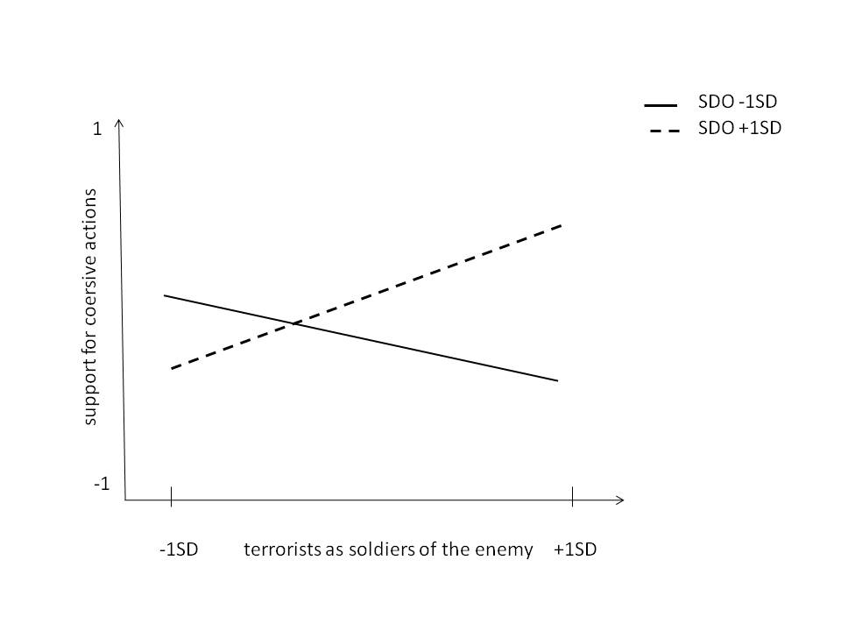
Figure 1.

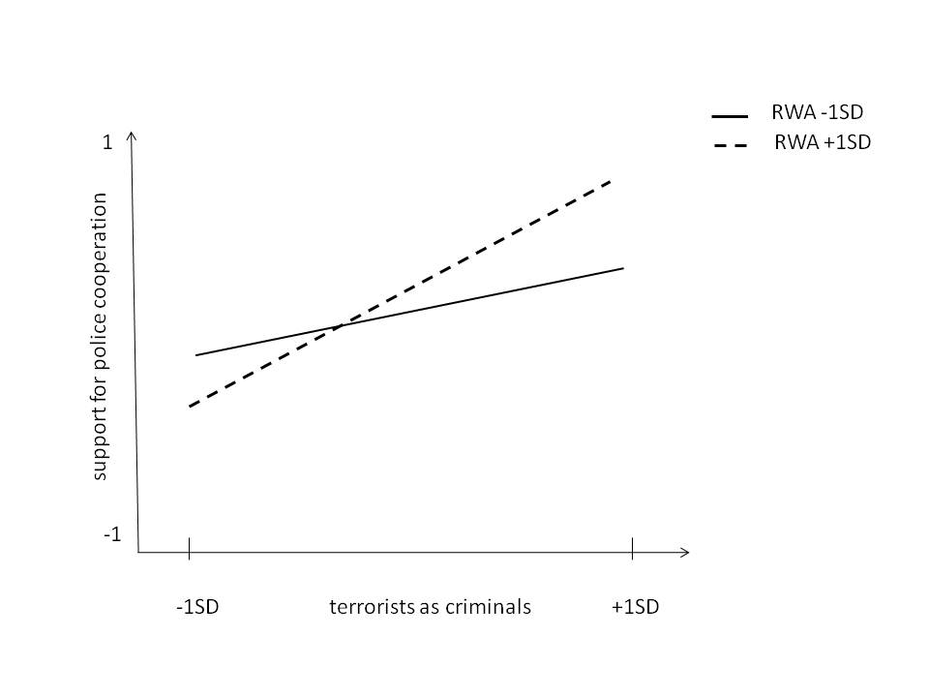
Figure 2.

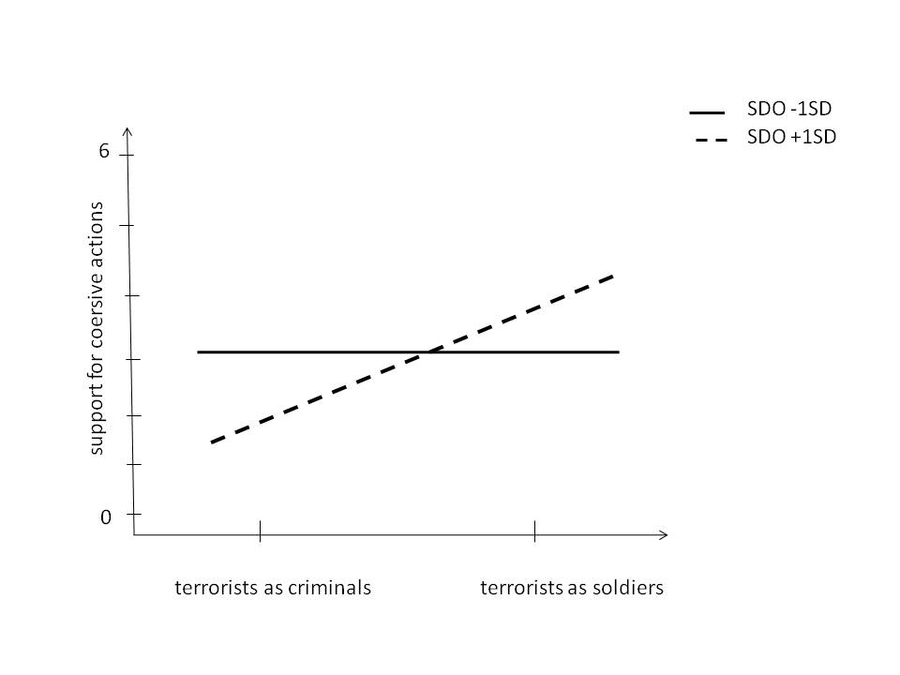
Figure 3.

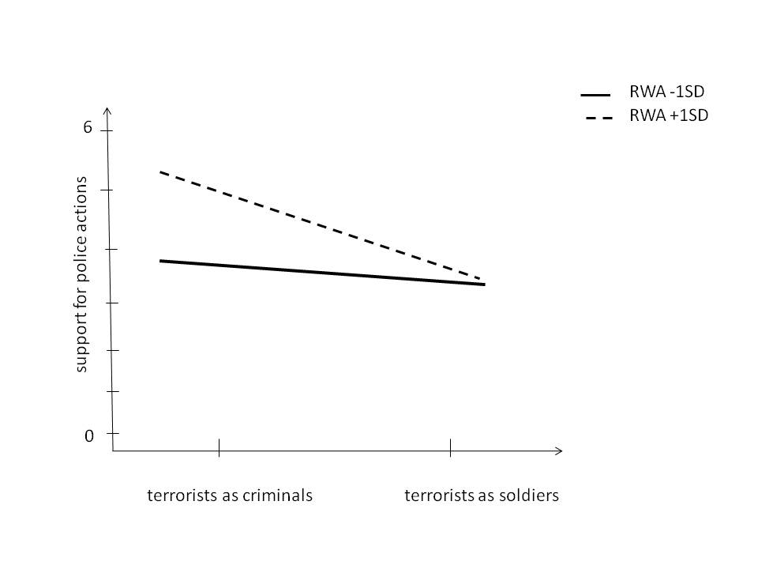

Figure 4.

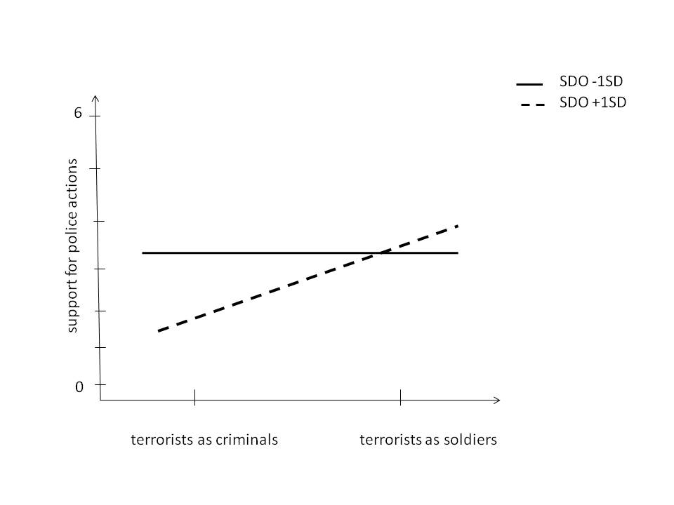

Figure 5.

Earlier studies confirm that authoritarians support aggressive counterterrorist actions. It is likely that the prevailing motivation behind support for such actions among authoritarians is the following of recommendations and call of the established group authorities (e.g. McFarland, 2005).
Nevertheless we performed the multiple regression analyses looking also at two other terrorist images and their interactions with authoritarianism and social dominance orientation. These analyses yield no other significant results that the ones discussed in the paper and they did not change the pattern of the reported results.
In order to exclude the possibility that the predicted interactions between authoritarianism and the perception of terrorist as criminals and between social dominance orientation and the perception of terrorists as soldiers are affected by intercorrelations between authoritarianism, social dominance orientation and other possible interactions between the ideological orientations and the two images, we performed another hierarchical multiple regression analysis that included all possible two way interactions of the four main predictors in step 2. These analyses do not reveal any other significant results and do not change the pattern of the results. In addition, we performed a series of analyses treating political conservatism as predictor rather than controlled variable and testing the interactive effects of terrorists’ perceptions and political conservatism. These analyses did not yield any additional significant results. .
We additionally performed a hierarchical multiple regression analysis that included all possible two way interactions of the three main predictors in step 2 and three-way interaction in step 3. These analyses did not reveal any other significant results and did not change the pattern of the presented results.
Additional multiple regression analyses were run adding the interaction between political conservatism and research conditions in step 2 and all three way interactions of ideological variables and research conditions in step 3. No other significant interaction was found and the presented pattern of results reminded unchanged.

