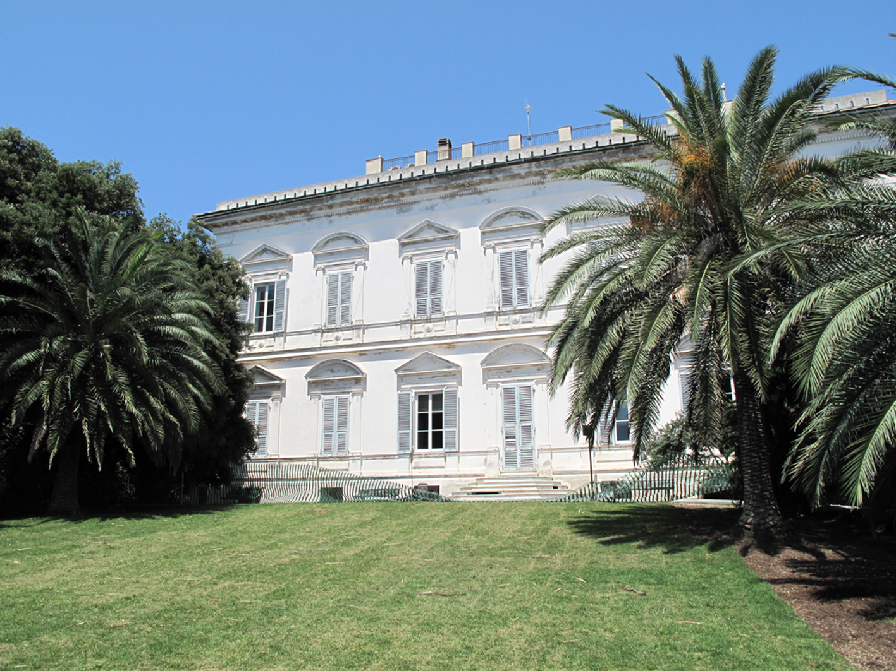
Museum of Contemporary Art, Villa Croce, Genoa

The Land Seen From the Sea
Little Constellation
Contemporary Art in geo-cultural micro areas and small States of Europe

Museum of Contemporary Art, Villa Croce, Genoa (I)

Curated by
Alessandro Castiglioni, Rita Canarezza & Pier Paolo Coro, Roberto Daolio, Francesca Serrati

Mussoni & Albani (F)(RSM); Yuula Benivolski (CA); Justine Blau (L); Canarezza & Coro (RSM); Martina Conti (RSM)(F); Nina Danino (GB); Hekla Dogg Jonsdottir (IS); Doris Drescher (L); Haris Epaminonda (CY); Paradise Consumer Group (AND); Xenia Uranova (RUS); Irena Lagator (MN); Ingibjörg Magnadóttir (IS); Mark Mangion (M); Agnès Roux (MC); Christodoulos Panayiotou (CY); Pierre Portelli (M); Luigi Presicce (I); Sigurður Atli Sigurðsson (IS); Giancarlo Norese e Umberto Cavenago (I); Trixie Weis (L); Martin Walch (FL); Anna Hilti (FL); Miki Tallone (CH); Jose Ramón Lozano (E).

Opening February 4th 2012, at 6.30 pm

From February 4 to May 4, 2012
from Tuesday to Friday open from 9.00 am to 6.30 pm
Saturday and Sunday from 10.00 am to 6.30 pm
Closed on Monday.

Program

Opening Saturday, February 4, 2012
at 6.30 pm - Presentation of the authorities and curators
performances at 7.00 pm: Martina Conti (RSM) (F), Ingibjörg Magnadóttir (IS).

Inauguration of the art works and installations:
Mussoni & Albani (F)(RSM); Yuula Benivolski (CA); Justine Blau (L); Canarezza & Coro (RSM); Martina Conti (RSM)(F); Nina Danino (GB); Hekla Dogg Jonsdottir (IS); Doris Drescher (L); Haris Epaminonda (CY); Paradise Consumer Group (AND); Xenia Uranova (RUS); Irena Lagator (MN); Ingibjörg Magnadóttir (IS); Mark Mangion (M); Agnès Roux (MC); Christodoulos Panayiotou (CY); Pierre Portelli (M); Luigi Presicce (I); Sigurður Atli Sigurðsson (IS); Giancarlo Norese e Umberto Cavenago (I); Trixie Weis (L); Martin Walch (FL); Anna Hilti (FL); Miki Tallone (CH); Jose Ramón Lozano (E).

Inauguration of works produced by the workshops and encounters of Little Constellation held on 14 and 15 October 2011 at the Library Archive of Little Constellation in San Marino, on 26 October 2011, at the MUDAM (National Museum of Modern Art of the Grand Duchy of Luxembourg) and 27 and 28 October 2011 at the Casino Luxembourg - Forum d’Art Contemporain in Luxembourg, from 6 to 8 November 2011 at the National Gallery of Iceland and the NYLO Living Art Museum; in Milan on 17 November 2011 at the Brown Project Space in Milano, with Malta Contemporary Art.
coordinators: Alessandro Castiglioni, Kevin Mouhlen, Enrico Lunghi, Halldór Björn Runólfsson, Mark Mangion, Oscar Carlson, Rita Canarezza & Pier Paolo Coro.

partecipants: Kristína Aðalsteinsdóttir, Bergur Thomas Anderson, Indíana Auðunsdóttir, Sigtryggur Berg Sigmarsson, Elísabet Brynhildardóttir, Hekla Dögg Jónsdottir, Baldvin Einarsson, Guðlaug Mía Eyþórsdóttir, Kristjana Rós Gudjohnsen, Rakel Gunnarsdottir, Guðni Gunnarsson, Helena Hansdóttir, Viktor Pétur Hannesson, Steinunn Harðardottir, Ólöf Helga Helgadóttir, Erik Hirt, Selma Hreggviðsdóttir, Bryndis Hrönn Ragnarsdottir, Ingvar Högni Ragnarsson, Loji Höskuldsson, Katrín I Jónsdóttir Hjördísardóttir, Ragnhildur Jóhannsdóttir, Gunnar Jónsson, Þorvaldur Jónsson, Ragnheiður Káradóttir, Gudri Lape, Sindri Leifsson, Tómas Lemarquis, Joseph Marzolla, Þórgunnur Oddsdóttir, Arna Óttarsdóttir, Helga Páley, Elín Anna Þórisdóttir, Helgi Þórsson, Lukka Sigurðardóttir, Ingibjörg Sigurjónsdóttir, Bjarki Sólmundsson, Jóhanna Kristbjörg Sigurðardóttir, Gudmundur Thoroddsen, Ólöf Thoroddsen, Björk Viggósdóttir.
Laurent Friob, Claudia Passeri, Saskia Raux & Marc Scozzai, Doris Drescher, Justine Blau, Patrick Galbats, Carine and Elisabeth Krecké, Bruno Baltzer, Leonora Bisagno, Marco Godinho, Gast Bouschet & Nadine Hilbert, Armand Quetsch, Mike Lamy.
Alireza Amirimoghaddam, Daniela Barulli, Clara Bastianelli, Martina Conti, Giovanni Giulianelli, Giovanni Lens Vincenzi, Maria Chiara Monaldi, Caterina Morganti, Fausta Morganti, Monica Moroni, Michela Pozzi, Sara Rossini, Valentina Toccaceli, Paolo Tognozzi, Marco Vincenzi.
* * *
until May 4, 2012 there will be a program of screenings, debates, round tables and workshops to keep up interest in the project and transform the exhibition into an active and involved focus of exchange and discussion.

February 5, 10:00 am
Workshop by Little Constelllation and Halldór Björn Runólfsson art historian and director of the National Gallery of Iceland.

February 25 (date subject to variation)
Presentation of the film of Amedeo Martegani
Desert Land

March (date subject to variation)
Lecture by Francesco Tedeschi, Professor of Contemporary Art, Catholic University of Milan.
Il mondo ridisegnato, Arte e geografia nella contemporaneità.

Saturday, April 21, 2012 (date subject to variation)
Third stage of the Little Constellation workshop TI'TANO.
After the first stage of Little Constellation at the Library Archive in San Marino, and the second part installed at the Living Art Museum in Reykjavik, the workshop will continue at the Museum of Villa Croce in Genoa with The Land Seen from the Sea, and then in Nottingham (UK), WEYA in September 2012. With these workshops for curators and artists under 30 years of age, Little Constellation is developing a particular project in collaboration with BJCEM for the XVIth Biennale of the Mediterranean - Ancona 2013.

* * *
The publication of the exhibition will take place at the end of the exhibition itself (the publication will also document the workshops and events described above) with a new co-production by all the Contemporary Art institutions of the Small States and micro areas involved, edited by Mousse Publishing, Milan, and international distribution by Motto, Berlin, Zürich, Wiels, Vancouver.
The event will be advertised and communicated via e-flux.com of New York and Mousse Magazine, Milan.

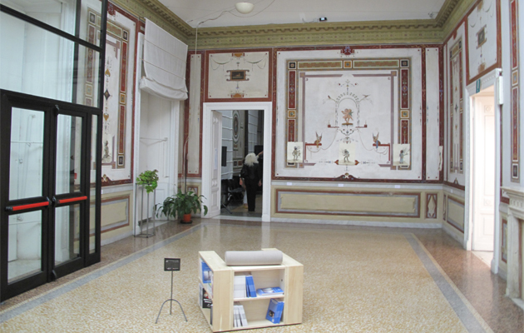
Museum of Contemporary Art, Villa Croce, Genoa

The concept of the exhibition.

Little Constellation is a project and an international network for contemporary art, which focuses its research on the symbolic sensitivity of the geographic dimension. Highlighting the different possible relationship between the geo-cultural centres and peripheries, through a plan of knowledge taken to the extreme of opposition and resistance between the concepts of proximity and distance, from January 2012, at the Museo di Villa Croce in Genoa, it will present the exhibition The Land Seen from the Sea.

In this respect, The Land Seen from the Sea, will be devoted in particular to the complex theme of isolation, which finds its definition in the dimension of the island (both in geographical terms, naturally, but also on the linguistic plane).

Isolation and the network of relationships are thus intertwined as fields of a single front. "We live around a sea like frogs around a pond," declared Socrates. This brings out the fact that the peoples of antiquity owed their prosperity and relations to the great sea (almost enclosed like a pond) that is the Mediterranean. It is this duality between distance and vicinity that the research project seeks to focus on.

This research therefore focuses on the Mediterranean by starting from particularly sensitive areas, such as Montenegro, Malta, San Marino, Monaco, Cyprus, Gibraltar (UK), Ceuta (E), and also other areas with which it is possible to make cultural and geographical comparisons, such as Iceland, Luxembourg, Andorra and Liechtenstein, Canton Ticino (CH), Kaliningrad (Rus).

The Museum of Villa Croce in Genoa becomes the crossroads of these two lines: one that cuts through the Mediterranean, and the one that runs through Europe, from San Marino to Reykjavik.

The preparation of this complex project has been developed in a particular dimension of dialogue, in collaboration with different institutions and artists that for years now are collaborating with the network.

Specifically, the multiple identities of the Mediterranean will be examined through three nuclear and seminal case studies, compared with the different cultures encountered in this small basin. These three areas are: Cyprus and its relations with Oriental cultures (Turkish, Arabic and Indian); Malta as a bridge between the North African basin and continental Europe. Gibraltar (and Ceuta), and relations with the Atlantic and English-speaking cultures.

This "longitudinal" survey is interwoven with a "transversal" research project which traverses Europe, starting from San Marino, taking in Luxembourg and travelling as far as Iceland, moving along a different line drawn ideally during a series of workshops curated by Rita Canarezza, Pier Paolo Coro and Alessandro Castiglioni, which were held:
- in San Marino on 14 and 15 October 2011 at Little Constellation Library Archive; - on October 26, 2011 in Luxembourg at the MUDAM www.mudam.lu/fr/agenda/details/event/little-constellation/ (National Museum of Modern Art of the Grand Duchy of Luxembourg); and on 27 and 28 October 2011 at the Casino Luxembourg - Forum of Contemporary Art of Luxembourg; - in Iceland from 6 to 8 November 2011 at the National Gallery of Iceland and the NYLO Living Art Museum; - in November 17, 2011, at the Brown Project Space, in Milan, with Malta Contemporary Art.

This series of workshops and presentations and, in particular, this exhibition in Genoa will provide an opportunity for new periods of research, shared creation and further opportunities for exchanging ideas and shared work between the artists, curators and art institutions involved, for the production of new projects and for future transnational activities of the Network of Little Constellation, already scheduled, including the exhibition of the Little Constellation Network, to be held in Iceland at the National Gallery of Iceland, in May - June 2013, with the Academy of Fine Arts in Reykjavik and in collaboration of other Museum of the city, during the Arts Festival in Reykjavik, one of the periods of highest international and cultural visibility of the city.

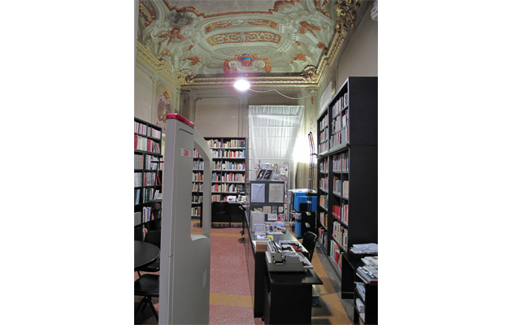

Libary - Museum of Contemporary Art, Villa Croce, Genoa

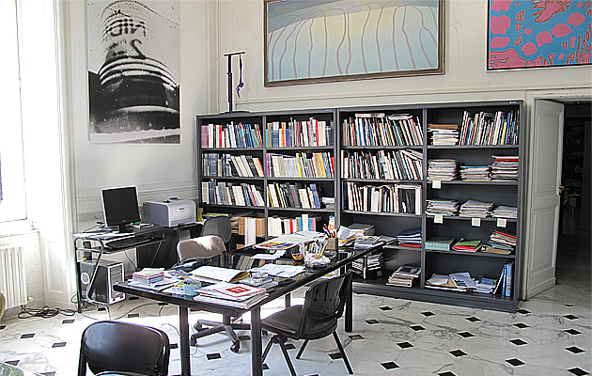

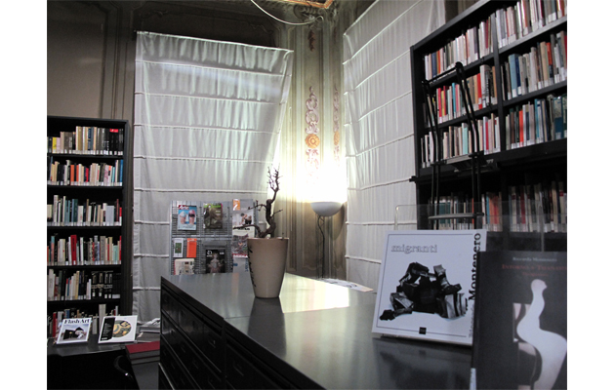

Library - Museum of Contemporary Art, Villa Croce, Genoa

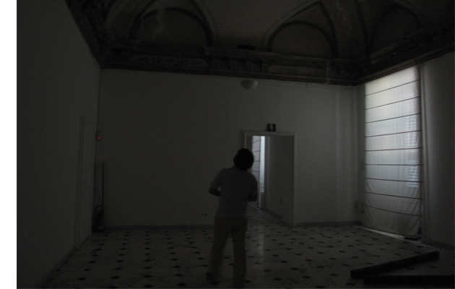

Exhibitions spaces - Museum of Contemporary Art, Villa Croce, Genoa

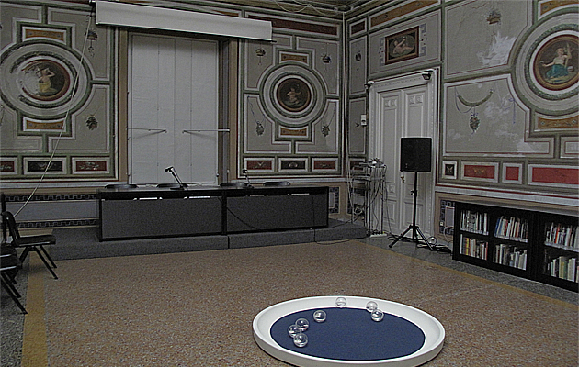

Conference Room - Museum of Contemporary Art, Villa Croce, Genoa

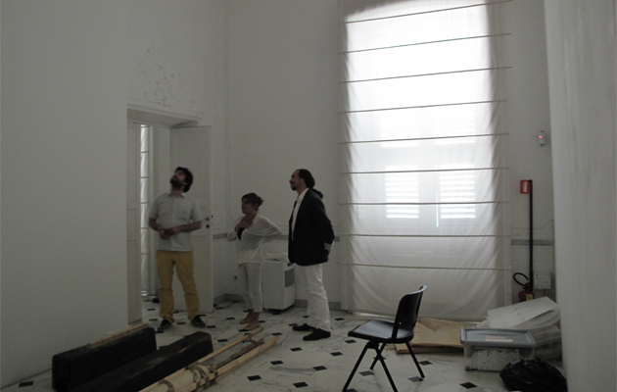

Exhibition spaces - Museum of Contemporary Art, Villa Croce, Genoa

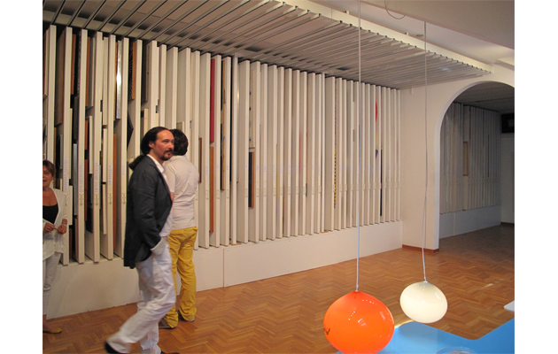

Archive - Museum of Contemporary Art, Villa Croce, Genoa

REPUBLIC OF SAN MARINO
Under the Patronage of the Most Excellent Regency of the Republic of San Marino
Secretary of State for Foreign and Political Affairs, Telecommunications and Transport
Secretary of State for Education and Culture, University and Youth Policies
Secretary of State for Sport and Tourism, Planning and Economic Relations with the AASS
Social and Cultural Activities Office

Fondazione San Marino, Cassa di Risparmio della Repubblica di San Marino SUMS, main sponsor
Ente Cassa di Faetano, Fondazione della Banca di San Marino, main sponsor

A Project by NUA New Contemporary Arts and Research
with the indispensable planning collaboration
of the Social and Cultural Activities Office

San Marino National Commission for UNESCO
Federazione Sammarinese Rugby, Club Rugby San Marino

CITY OF GENOA – ITALY
Municipality of Genoa
Department for the promotion of the City and Cultural Projects
Museo d’Arte Contemporanea, Villa Croce
Genova Palazzo Ducale Fondazione per la Cultura
Consulate of San Marino in Genoa

LUXEMBOURG
Ministry of Culture and Research of Luxembourg
FOCUNA, National Cultural Fund of Luxembourg
MUDAM Luxembourg - Musée d’Art Moderne Grand-Duc Jean
Casino Luxembourg - Forum d’Art Contemporain

ICELAND
Ministry of Foreign Affairs of Iceland
Ministry of Culture of Iceland
Cultural Affair Office of Iceland
National Gallery of Iceland
CIA.IS Centre for Icelandic Arts
Living Art Museum
SIM

CYPRUS
Ministry of Education and Culture of Cyprus
Cultural Services Cyprus
The Nicosia Municipal Arts Centre, Cyprus

MALTA
Undersecretary of State for Tourism, The Enviroment and Culture
Permanent Secretariat, OPM, Tourism Culture & Sustainable Development
Malta Council for Culture and the Arts
Malta Contemporary Art

LIECHTENSTEIN
Government of the Principality of Liechtenstein
Ministry Foreign Affairs, Justice and Cultural Affairs of Liechtenstein
Kulturstiftung Liechtenstein
BBKL Liechtenstein
Kunstmuseum Liechtenstein

MONTENEGRO
Government of Montenegro
Ministry for Culture, Sports and Media
Ateljer Dado, National Museum of Montenegro, Cetinje
Montenegrin National Theater
Centre for Contemporary Art, Podgorica, Montenegro

GIBRALTAR (UK)
Ministry of Culture, Heritage, Sport & Leisure, Gibraltar (UK)
Fine Arts Association Gallery
Radio Gibraltar Broadcasting Corporation

KALININGRAD REGION (RUSSIA)
Ministry of Culture of the Kaliningrad Region (Rus)
Department of the Kaliningrad Regional Government
Kaliningrad Branch of The National Centre for Contemporary Arts

ANDORRA
Ministry of Culture
Serveis Culturals Andorra
Escola d’Art la Llacuna, Andorra La Vella, Andorra

CANTON TICINO (CH)
Museo Cantonale d’Arte, Lugano
La Rada, Locarno

CEUTA (E)
Direzion Provincial de Educacion
Instituto De Bachillerato Siete Colinas,
Casa de la Juventud, Ceuta

MONACO
Le Logoscope

Little Constellation kindly asks to each country to support the production of the works of their own artists, travel expenses for the artists and cultural/institutional representatives, as well as to offer a contribution for the publication of the catalogue to be realised at the end of the exhibition, as a coo-production of the entire project.

Participation procedures for institutions
Little Constellation - The Land Seen From the Sea

a confirmation possibly by January 10, 2012

1 A letter of response (to the addresses below), indicating the support of:
. travel of artists and curators of their own country, (for the opening of the February 4, 2012) and collaboration in the realization of the art works by the invited artists (when requested by the artists) and participation in the final publication of the exhibition with a bank transfer of 1,500 Euros (see point 4) edited by Mousse Publishing.
2 Sending the logos of participating institutions
3 Communication of people (artists, curators and personality) for hospitality (thanks to the consillor for the promotion of the City and Cultural Project of the Municipality of Genoa, artists and curators invited by Little Constellation, will be a guests for the opening).

Little Constellation Library Archive
Contemporary Art in geo-cultural micro areas and Small States of Europe
NUA new contemporary art and research
Strada Lamaticcie Serravalle 47890
Repubblica di San Marino
nua@omniway.sm

Social and Cultural Activities Office
Secretary of State for Education and Culture, University and Youth Policies of Republic of San Marino
Via Ventotto Luglio 192, 47890
Repubblica di San Marino
Fax 00378 0549 882300
sezione.cultura.uasc@pa.sm

Possibly, by January 31, 2012

4 credit of Euro 1,500
international wire transfer to:
Beneficiary: Associazione Culturale NUA
Beneficiary Bank and branch: Cassa di Risparmio della Repubblica di San Marino, Domagnano
SWIFT: CSSMSMSM
Iban: SM3I K 06067 09814 000000403301
Reason: The Land Seen From The Sea

The publication of the exhibition will take place at the end of the exhibition itself (the publication will also document the workshops and events described above) with a new co-production by all the Contemporary Art institutions of the small States and micro areas involved, edited by Mousse Publishing (www.moussepublishing.com), and distributed by Motto of Berlin, Zürich, Wiels, Vancouver (www.mottodistribution.com).

Do not hesitate to call us, or write for information or clarification:
Social and Cultural Activities Office, sezione.cultura.uasc@pa.sm, tel. 00378 0549 882453 - 882452 tel. 00378 0549 904128
Nua new arts and contemporary research, nua@omniway.sm; nua@littleconstellation.org
0039 338 1935637 (Pier Paolo Coro) 0039 335 6509052 (Rita Canarezza)
0039 3400869115 (Alessandro Castiglioni) castiglioni@littleconstellation.org

for information about the Little Constellation network:
www.littleconstellation.org
www.mudam.lu/fr/agenda/details/event/little-constellation/
www.moussepublishing.com/printed/LittleConstellation/littleconstellation.php
www.mottodistribution.com/site/?p=5977
www.undo.net/it/videofocus/1269166003
www.e-flux.com/shows/view/7832
www.e-flux.com/shows/view/2395
www.maltacontemporaryart.com
www.culturalpolicies.net/web/sanmarino.php?aid=244
https://shop.gestalten.com/index.php/catalog/product/view/id/683

Little Constellation Library Archive
Contemporary Art in geo-cultural micro areas and small States of Europe
c/o NUA new contemporary Arts and research
Str. Lamaticcie 54, Serravalle 47890
Republic of San Marino
nua@omniway.sm
nua@littleconstellation.org
www.littleconstellation.org
tel. 00378 0549 904128
0039 338 1935637 – 0039 335 6509052

Secretary of State for Education and Culture, University and Youth Policies of Republic of San Marino
Social and Cultural Activities Office
Via Ventotto Luglio 192, 47890
Republic of San Marino
Fax 00378 0549 882300
Phone 00378 0549 882453 - 882452
sezione.cultura.uasc@pa.sm

Little Constellation
PRESS OFFICE
METAMUSA arte ed eventi culturali
Via Cerase Battisti, 9
21013 Gallarate VA Italy
tel./fax 0039 0331 777472
info@metamusa.it

