The “Haunt” Project: An attempt to build a “haunted” room
by manipulating complex electromagnetic fields and infrasound

Christopher C. French¹, Usman Haque², Rosie Bunton-Stasyshyn¹ & Rob Davis¹

¹Anomalistic Psychology Research Unit
Department of Psychology
Goldsmiths College

²Haque Design + Research

Running title: The “Haunt” Project

Corresponding author: Professor Christopher C. French, Anomalistic Psychology Research Unit, Department of Psychology, Goldsmiths College, University of London, New Cross, London SE14 6NW. Email: c.french@gold.ac.uk. Tel: 020 7919 7882. Fax: 020 7919 7873.

Abstract: Recent research has suggested that a number of environmental factors may be associated with a tendency for susceptible individuals to report mildly anomalous sensations typically associated with “haunted” locations, including a sense of presence, feeling dizzy, inexplicable smells, and so on. Factors that may be associated with such sensations include fluctuations in the electromagnetic field and the presence of infrasound. A review of such work is presented, followed by the results of the “Haunt” project in which an attempt was made to construct an artificial “haunted” room by systematically varying such environmental factors. Participants (N = 79) were required to spend 50 minutes in a specially constructed chamber, within which they were exposed to infrasound, complex electromagnetic fields, both or neither. They were informed in advance that during this period they might experience anomalous sensations and asked to record on a floor-plan their location at the time occurrence of any such sensations, along with a note of the time of occurrence and a brief description of the sensation. Upon completing the session in the experimental chamber, they were asked to complete three questionnaires. The first was an EXIT scale asking respondents to indicate whether or not they had experienced particular anomalous sensations. The second was the Australian Sheep-Goat Scale, a widely used measure of belief in and experience of the paranormal. The third was Persinger’s Personal Philosophy Inventory, although only the items that constitute the Temporal Lobe Signs Inventory (TLS) sub-scale were scored. These items deal with psychological experiences typically associated with temporal lobe epilepsy but normally distributed throughout the general population. Although many participants reported anomalous sensations of various kinds, the number reported was unrelated to experimental condition but was related to TLS scores. The most parsimonious explanation for our findings is in terms of suggestibility.
Keywords: Haunt-type experiences; infrasound; electromagnetic fields; temporal lobes; paranormal belief.
Introduction
A recent poll by the Gallup Organization showed that 37% of Americans believed in haunted houses (Musella, 2005). A previous poll of British adults by MORI showed that 40% believed in ghosts and, of these, 37% claimed to have personally experienced a ghost (MORI, 1998). Clearly, personal experience plays a large part in producing belief in ghosts and haunted locations, but how are we to explain such experiences? A number of theories have been proposed (McCue, 2002).

People can often come to believe that their house or workplace is haunted following an initial unusual experience that seems to them only to be explicable in paranormal terms. That initial event may be psychological in nature (e.g., a frightening episode of sleep paralysis; see French and Santomauro, 2007) or some physical event that defies any obvious explanation (e.g., an item of furniture that appears to have moved when the house was locked and empty). Tandy and Lawrence (1998, p. 360) suggest a number of obscure non-paranormal causes of ostensible ghostly activity including “water hammer in pipes and radiators (noises), electrical faults (fires, phone calls, video problems), structural faults (draughts, cold spots, damp spots, noises), seismic activity (object movement/destruction, noises), […] and exotic organic phenomena (rats scratching, beetles ticking)”.

As one might expect, the effects of context and belief in ghosts (and the paranormal in general) all play a part in determining whether or not a particular location will be perceived as being haunted (and by whom). For example, Lange and Houran (1997) asked two groups of participants to walk around a disused cinema and to note whether they experienced any cognitive, physiological, emotional, psychic, and spiritual responses in reaction to their surroundings. Half of the participants were simply told that the property was currently being renovated whereas the other half was told that paranormal activity had been reported there. As predicted, the latter participants reported significantly more physical, emotional, psychic, and spiritual experiences than those in the former group. Wiseman, Watt, Greening, Stevens, and O’Keeffe (2002) collected data from 678 participants walking around Hampton Court Palace, reported to be one of the most haunted locations in England. Those who believed in ghosts reported more unusual experiences as they walked around than did non-believers and they were also more likely to attribute these experiences to ghostly intervention.

It has recently been argued that certain environmental factors associated with particular locations may be directly causing susceptible individuals to experience anomalous sensations. Lange, Houran, Harte, and Havens (1996) point out that the anomalous sensations typically associated with haunted locations include a diverse range of phenomena from fairly mild experiences, such as perceived sudden changes in temperature, unusual odours, and a sense of presence, up to full-blown apparitions. Such phenomena, it has been suggested, may be induced in some people by exposure to unusual geomagnetic and electromagnetic fields (Braithwaite, 2004; Persinger and Koren, 2001; Roll and Persinger, 2001). Such unusual fields could have a number of causes including the natural variability in the Earth’s field, movements of tectonic plates against each other, local geological factors such as quartz-based rock and magnetic mineral properties, and man-made electrical devices (e.g., Braithwaite, 2004).

The first line of evidence to support this notion comes from a number of studies that have measured the electromagnetic fields in reputedly haunted locations. Electromagnetic fields at any specific location constantly vary both spatially and temporally. Some studies have found that reputedly haunted locations show unusual overall levels in the electromagnetic fields present (e.g., Nichols and Roll, 1999; Persinger, Koren, and O’Connor, 2001), some that the variability and complexity of the field is unusual (e.g., Persinger and Cameron, 1986; Wiseman, Watt, Stevens, Greening, and O’Keeffe, 2003), some that both ambient levels and variability are unusual (e.g., Braithwaite, 2004; Braithwaite, Perez-Aquino, and Townsend, 2004; Braithwaite and Townsend, 2005), and a few find no field anomalies at all (e.g., Maher, 2000). Furthermore, Persinger (1985) claims that reports of anomalous experiences, including those associated with poltergeist activity (Gearheart and Persinger, 1986), tend to occur more often during periods of heightened geomagnetic activity caused by tectonic stresses in the Earth’s crust (but see Rutkowski, 1984, and Wilkinson and Gauld, 1993, for critiques).

As pointed out by Braithwaite (2004), one major problem with this approach is the relative lack of time-linked (i.e., synchronized) recordings at both a reputedly haunted location and a reputedly non-haunted comparison location (see also Houran and Brugger, 2000). Without such data, it is quite possible that as many magnetic anomalies exist in both types of environment especially given the inconsistency of results reported from the reputedly haunted locations. Furthermore, Braithwaite emphasizes the need for simultaneous recordings from both target and baseline control sites in order to eliminate the possibility that a time-based difference is misinterpreted as a spatial difference. If recordings are not taken simultaneously, it is possible, for example, that anomalous fields were occurring at both sites during the first recording and neither during the second. If the first recording was at the “haunted” site, investigators might erroneously conclude that they have further evidence for the EMF hypothesis. Braithwaite provides evidence from his own study, using simultaneous recordings from haunted and nearby baseline areas, that the magnetic field was indeed unusual at the former whilst simultaneously no unusual fields were recorded at the latter but such studies are rare to date.

The idea that field complexity may be more important than overall ambient field strength in inducing such experiences is supported by a further line of evidence, that is, results from laboratory-based studies. Across a series of studies, Persinger and colleagues (e.g., Cook and Persinger, 1997; Persinger, 2001) claim to have induced anomalous experiences, including in one case that of a full-blown apparition (Persinger, Tiller, and Koren, 2000), by exposing the temporal lobes of the brain to transcerebral complex magnetic fields. It is claimed that such effects are particularly likely in participants with labile temporal lobes who will tend to score highly on Makarec and Persinger’s (1990) Temporal Lobe Signs (TLS) scale. For example, Cook and Persinger (2001) reported that six out of eight participants with high scores on the TLS felt a presence upon being exposed to transcerebral complex magnetic fields, whereas none of their eight low-scoring participants did. The exact mechanism whereby exposure of the temporal lobes to complex magnetic fields could cause anomalous experiences in susceptible individuals is not yet clear. Braithwaite (2004, p. 6) argues that the fact that such effects only seem to occur in the laboratory after prolonged exposure (20-30 minutes) suggests that “the mechanism of interaction is a subtle one perhaps at the level of psychopharmacological effects between synapses of neurons or increased hyper-polarisation of specific inhibitory neuronal systems.” The consequences of such effects might be neuronal disinhibition producing altered mental states and hallucinations.

Unfortunately, until very recently there had been no attempt by independent investigators to replicate Persinger’s research using transcerebral complex magnetic fields. One such attempt was recently reported, however, by Granqvist, Fredrikson, Unge, Hagenfeldt, Valind, Larhammar, and Larsson (2005). Granqvist et al. carried out a double-blind study (N = 89), comparing the effects of transcerebral complex magnetic fields with sham-fields. They found no evidence that magnetic fields induced sensed presence, mystical, or other somatosensory experiences, but personality measures such as absorption, TLS scores, and orientation towards a New-age lifestyle did predict the occurrence of such experiences. They therefore argued that the effects previously reported by Persinger and colleagues may well be nothing more than the effects of suggestibility manifesting themselves in experiments with inadequate use of double-blind procedures. Persinger and Koren (2005) have robustly rejected such criticism, claiming that their work does make use of adequate double-blind procedures and pointing out what they felt were methodological problems with Granqvist et al.’s replication attempt. However, Larsson, Larhammer, Fredrikson and Granqvist (2005) were not persuaded by the objections put forward and remain convinced that Persinger had indeed failed to ensure proper double-blind methodology. Clearly, further research is urgently needed in this potentially fruitful, if controversial, area.

Another suggested cause of anomalous experiences is the presence of infrasound, that is, sounds of such a low frequency that they are outside the audible range for human beings. Tandy and Lawrence (1998) produced evidence that a standing wave at a frequency of 18.9 Hz was present in a factory in which several workers had had unusual experiences, including Tandy himself who reported seeing an apparition in his peripheral visual field. In a subsequent investigation, Tandy (2000) showed that infrasound at 19 Hz was present in a 14th century cellar beneath the Tourist Information Centre in Coventry. Several visitors to the cellar had previously reported anomalous sensations including a sense of presence and apparitions.

Braithwaite and Townsend (2006) have argued strongly that the case to date for a specific role for infrasound in inducing haunt-type experiences is weak. Amongst their criticisms, they note that there is a lack of comparison baseline data relating to this hypothesis. It is unclear how often infrasound would be recorded from reputedly non-haunted locations and therefore one is once again faced with the possibility that the hypothesis is based upon the positive-test fallacy. Without data relating to the presence or absence of infrasound at both reputedly haunted and non-haunted locations, one simply cannot properly assess the validity of this hypothesis. Experimental studies of the effects of directly manipulating the presence or absence of infrasound, as in the current study, offer a powerful alternative approach to testing the hypothesis.

Braithwaite and Townsend (2006) also criticise the neuropsychological mechanism proposed by Tandy and Lawrence (1998) to explain the postulated effects of infrasound. Tandy and Lawrence had proposed that the effects may be produced as a direct consequence of infrasound inducing vibration in the human eyeball due to resonance. Braithwaite and Townsend present a detailed critique of this argument pointing out, amongst other things, that such vibration would be expected to produce visual distortion across the entire visual field rather than just in peripheral vision and that, furthermore, such vibration would be unlikely to produce complex and sustained hallucinatory experiences. Such visual effects have not been reported in previous investigations of the effects of infrasound. However, the notion that both infrasound and EMF anomalies might contribute to explaining some haunt-type experiences has gained considerable popularity thanks to widespread dissemination in the media, despite the relative lack of strong supporting evidence, to the extent that the current attempt to investigate the possible effects of these factors experimentally was felt to be justified.

The current experiment therefore reports an initial attempt to investigate whether, based upon this previous research and speculation, it would be possible to artificially construct a “haunted” room. Specifically, we wanted to investigate whether exposure to complex EMFs, infrasound, or both in combination would lead participants to experience more anomalous sensations compared to a baseline condition. The artificial room used was completely empty, white, and circular. Informal pilot testing had suggested that dim illumination and a cool temperature would be the most suitable conditions for this study, insofar as they are the conditions typically associated with reputedly haunted locations.

Participants were asked to spend 50 minutes in the room and to record on a floor-plan a brief description of any anomalous sensations they experienced, where they were when the experience occurred and the time at which it occurred. A version of the EXIT scale (Persinger et al., 2000), which asks respondents whether specific anomalous sensations have occurred, was also employed in this study. Participants were asked to complete the EXIT scale upon leaving the room. It was hypothesised that a greater number of unusual experiences would be recorded on the floor plan and that higher scores on the EXIT scale would be found for those participants exposed to EMF and/or infrasound. Essentially, these two scores were both measuring the number of experiences reported, using open-ended and closed methodologies, respectively. Additionally, it was hypothesised that those scoring high on the TLS scale might be particularly susceptible to the effects of EMF. Alternatively, if previously reported effects were due mainly to suggestibility, we might find that the actual condition in which participants were run would not have an effect but those scoring higher on the TLS and ASGS scales would report more unusual experiences anyway.

Method
Participants
A total of 79 volunteer participants (45 male) took part in the experiment, with a mean age (in years) of 32.25 (SD = 8.1, minimum = 21, maximum = 61). Participants were recruited through web sites (e.g., www.haque.co.uk ) and email lists (e.g., UH’s own email list and the Bartlett Architecture School and English Language students at a London school).

Design and Statistical Analyses
The study employed a 2 (EMF present vs. EMF absent) x 2 (infrasound present vs. infrasound absent) design. Details of the generation and presentation of the EMF and infrasound are presented below. Participants were allocated to condition on a random basis (by UH), resulting in the following distribution of participants across conditions: EMF absent, infrasound absent (18; 13 male, 5 female); EMF absent, infrasound present (20; 12 male, 8 female); EMF present, infrasound absent (23; 9 male, 14 female); EMF present, infrasound present (18; 11 male, 7 female).

The primary hypotheses of the study were investigated using two separate hierarchical multiple regressions, one to predict the EXIT scores and one to predict the total number of experiences reported. In each case the predictor variables entered on the first step were the centred TLS and ASGS scores, along with presence/absence of EMF and infrasound (dummy coded as 0 = absent and 1 = present). The predicted interaction between EMF and TLS scores was investigated by entering the cross-products of these variables as the second step in the regression analyses.

Materials and Equipment
Care was taken to ensure that the levels of infrasound and the varying EMF fields were all completely safe and full ethical approval was obtained from the Goldsmiths College Ethics Committee for this project. It was important that participants would not be consciously aware of the presence of infrasound during the experiment proper and so pilot tests were run to determine the level to be used. At high intensities, one can actually feel infrasound even though it cannot be heard. Pilot participants (N = 15) were asked to indicate by means of a button-press at what point they became aware that a stimulus was being played to them on each trial in which the stimulus volume rose from silence to full volume over 22 seconds. Participants were informed that no stimulus would be played to them on half the trials. The trials when a stimulus was played to them consisted of three trials each at the following frequencies: 15Hz, 17Hz, 19Hz, 21Hz, 23Hz and 25Hz. It was thus established that no participant was able to perceive infrasound at a level below 75dB. No such pilot testing was deemed necessary for the EMF stimulation, as such fields are never consciously perceived.

The infrasound waveform used was generated by combining two sine waves at 18.9Hz and 22.3Hz (frequencies that correspond to two of the peaks noted by Tandy, 2000) to create a more “complex” waveform that had somewhat similar characteristics to that recorded in Coventry. This was amplified and output through a purpose-built cabinet at a level that was determined from prior experimentation to be below the general ability of human beings to perceive consciously. Measurements indicated that the background noise level in the experimental chamber with all equipment switched off was 50dB and 65dB with the air-conditioning switched on. With infrasound switched on, the noise level was 75dB.

The magnetic field waveform was based upon that used by Persinger (e.g., Persinger, Tiller, and Koren, 2000). The Persinger burst pattern was generated by constructing a table of values from the graph of the waveform used and then converting these numeric values into a 16-bit .wav file using Goldwave (software) at a sample rate of 1000Hz for playback via the computer’s soundcard. This was output via the computer’s soundcard and amplified to drive two coils set next to the wall of the space but hidden behind it; the first was 100 turns of 1200mm diameter, the second was 200 turns at 800mm diameter. The combined output level was calibrated so that at its maximum it was under 50,000nT. At all stages, including the actual output in the space, the accuracy of the signal was monitored by oscilloscope.

A circular featureless chamber measuring approximately 3m in diameter and 4m high was built using white canvas on a slotted axle frame inside a standard row house apartment in North London. The temperature was approximately 18 degrees Celcius and the light level was about 1 lux (see Figures 1 and 2). As can be seen from Figure 1, most of the EMF output was concentrated in one quadrant of the experimental space (the diagram illustrates the areas where the output is greater than 25 and 5uT, respectively).
--- Insert Figures 1 and 2 about here ---
Participants signed an informed consent form before entering the experimental room and completed three scales upon leaving the room. The first was an EXIT scale containing 20 items asking if specific anomalous sensations had been felt (e.g., “Felt dizzy or odd”, “Felt a presence”, “Tingling sensations”, and so on). Items were responded to as either “True” or “False” and the total score across the whole scale was recorded. Note that previous studies employing the EXIT scale (e.g., Granqvist et al., 2005) have used a format with three response options (0 = never, 1 = occasionally (or at least once), and 2 = frequently). The change in response format was the result of a simple oversight. Granqvist et al. (2005) reported that the internal consistency across items was sufficient (Cronbach’s alpha = .71) in their version of the EXIT scale to justify the creation of an average score across items. The unintentional change in response format had very little effect on internal consistency across items in the current study, lowering Cronbach’s alpha very slightly to .68. Therefore, responses were summed across items to give a total EXIT scale score (theoretical maximum = 20).

The second scale administered was the True-False version of the Australian Sheep-Goat Scale (ASGS). The ASGS is designed to measure belief in, and alleged experience of, the paranormal. It consists of 18 items that all relate specifically to the three core concepts of parapsychology: ESP (extrasensory perception), PK (psychokinesis), and life after death. Example items are “I believe I have personally exerted PK on at least one occasion” and “I believe in life after death”. For all items, the response options are “True”, “?” (i.e., don’t know) and “False” resulting in a score of 2, 1 or zero points, respectively. Thus, the scale has a theoretical range from zero to 36, with higher scores indicating higher levels of belief and experience. The ASGS has been widely used and has proven reliability and validity (Thalbourne, 1995; Thalbourne and Delin, 1993).

Finally, participants completed the 140-item Personal Philosophy Inventory, but only the 30 items constituting the Temporal Lobe Signs (TLS) scale were scored (Makarec and Persinger, 1990). These items relate to psychological experiences typically associated with temporal lobe epilepsy, but normally distributed in the general population, such as “Sometimes an event will occur which has special significance for me only” and “People tell me I ‘blank out’ sometimes when we are talking”. According to Persinger, high scorers are particularly susceptible to EMF variability. The items are presented with a True-False response format and the number of “true” responses is tallied. The internal consistency and validity of the scale have been established (Makarec and Persinger, 1990).

Procedure
Essentially, the experiment involved asking participants to spend 50 minutes alone wandering around inside the experimental room. During their time in this space they were asked to record any unusual sensations that they felt and to mark the spot on a floor plan at which the sensation occurred, along with the time at which it occurred and a brief description of the experience. Participants were informed in advance that they might be exposed to varying EMFs, infrasound, both or neither, and that they might experience mildly unusual sensations as a result. Upon completing 50 minutes in the room, participants completed the three questionnaires and were fully debriefed.
Results
Descriptive Statistics and Preliminary Analyses
As participants were recruited from web sites and via email lists, it was possible that the sample recruited might show markedly higher levels of paranormal belief than the general population. However, the overall mean ASGS score for the sample was 12.97 which is similar to that found in other studies using the ASGS in which participants were not recruited in this way (e.g., Thalbourne, 1998; Wilson and French, 2006). Thus the sample appeared to be reasonably representative of the general population.

Note that in all reported analyses, it is recognised that there will always be a naturally occurring background field; “EMF present” refers to the presence of our artificially produced field over and above this naturally occurring background. Summary data are presented in Table 1.
--- Insert Table 1 about here ---
Initially, 2-way between-groups ANOVAs were performed separately on the ASGS and TLS scores with Infrasound (present vs. absent) and EMF (present vs. absent) as factors. No significant main effects or interactions were found, showing that the random allocation of participants to conditions had not resulted in unintentional sampling biases (see Table 1). The highest F-value for the ASGS analysis was that associated with the Infrasound x EMF interaction (F(1, 75) = 2.77, p = .10), whilst that for the TLS analysis was that associated with the main effect for Infrasound (F(1, 75) = 2.05, p = .16).

Examination of the distribution of scores on the EXIT scale revealed that most participants reported some unusual sensations (Table 1). Only 6.3% reported none and around 70% reported three or more. However, the distribution was quite positively skewed as was the distribution for the total number of experiences reported on the floor plan. Following Howell (1987, p. 305), both sets of data were transformed to normalise the distributions using the following transformation: Transformed score = square root (original score) + square root (original score + 1). All further analyses were performed on the transformed scores.

Across all participants, TLS scores correlated significantly with both the total number of experiences reported (r = .31, p = .006) and the EXIT scale scores (r = .49, p < .001). ASGS scores correlated significantly with TLS scores (r = .52, p < .001) and EXIT scale scores (r = .35, p = .002), but the correlation between ASGS scores and the total number of experiences reported on the floor plan failed to reach significance (r = .20, p = .08).

Primary Analyses
Two hierarchical multiple regression analyses were carried out, one on the EXIT scale scores and one for the total number of experiences reported on the floor plan, using the simultaneous entry (ENTER) method. In each case, the centred TLS and ASGS scores, along with presence/absence of EMF and infrasound (dummy coded as 0 = absent and 1 = present) were entered on the first step as the predictor variables. The hypothesised two-way interaction between EMF and TLS scores was examined in the second step by entering cross-products of these two variables. Results of analyses for transformed EXIT scores and transformed total number of experiences are presented in Tables 2 and 3, respectively.
--- Insert Tables 2 and 3 about here ---
Both analyses revealed a similar pattern of results. In each case, on both EXIT scale and floor plan, the only significant predictor of the number of unusual experiences reported was the TLS score. EMF condition, infrasound condition and ASGS scores were not significantly related to either measure and neither, crucially, was the hypothesized interaction between EMF condition and TLS scores.

Many participants in our study who spent 50 minutes in the experimental room reported anomalous sensations of various sorts. The EXIT scale revealed, for example, that 63 (79.7%) of the participants felt dizzy or odd, 39 (49.4%) felt like they were spinning around, 33 (41.8%) experienced recurrent ideas, 29 (36.7%) felt tingling sensations, 26 (32.9%) felt that they were somewhere else, 25 (31.6%) felt pleasant vibrations through their bodies, 20 (25.3%) heard a ticking sound, 18 (22.8%) felt detached from their bodies, 18 (22.8%) felt a presence, 9 (11.4%) experienced sadness, 8 (10.1%) remembered images from recent dreams, 8 (10.1%) experienced odd smells, 7 (8.9%) experienced terror, and 4 (5.1%) experienced sexual arousal.

Secondary Analysis
As illustrated in Figure 1, most of the EMF output was concentrated in one specific quadrant. However, a planned related t-test revealed that no more unusual sensations were experienced in this quadrant than the average for the other three quadrants in those participants exposed to complex EMFs (t(40) = .85, not sig.).

Discussion
As can be seen from the Results section, many of the participants in this experiment reported experiencing mildly anomalous sensations. To this extent, we can indeed claim some success in building a haunted room. It is possible that the experimental set-up used in this study (a quiet, round, cool, dimly lit, featureless white room) may have constituted a form of mild perceptual deprivation that was sufficient to induce a hallucinatory altered state of consciousness in some participants. Although the set-up differed in significant ways from that used in Ganzfeld studies, the work of Wackermann et al. (this issue) may be of relevance here. Furthermore, some of the auditory experiences reported by our participants may be a consequence of hyperacusis (Dubal and Viaud-Delmon, this issue).

However, the degree to which these anomalous sensations were reported was unrelated to the experimental conditions employed. Given that all participants were informed in advance that they might experience unusual sensations whilst in the chamber (in line with the ethical requirements of informed consent), the most parsimonious explanation of our findings is in terms of suggestibility. Such an explanation is supported by the fact that TLS scores, known to correlate with suggestibility (Granqvist et al. 2005), significantly predicted both the total number of anomalous experiences reported on the floor-plan and the scores on the EXIT scale. We feel that the data collected cast some light upon the psychology of hauntings. A considerable proportion of the participants reported a number of anomalous sensations in response to a fairly mild suggestion that in our white, round, featureless room they might feel some unusual sensations. Such an explanation is in line with the observations of Houran and Lange (1996). They asked two volunteers to keep a diary for 30 days of unusual events of the type that are traditionally associated with hauntings and poltergeists in a residence with no prior history of such activity. As expected, the instructions themselves were sufficient for the volunteers to note, with increasing frequency, anomalous or unusual events presumably simply because the volunteers were now primed to notice such phenomena.

Our findings also failed to provide any support for the postulated link between the presence of infrasound and the experiencing of anomalous sensations. It is possible that such effects may be found under different conditions to those employed in the present study. However, it is worth noting that Braithwaite and Townsend (2006) have recently strongly questioned the empirical basis for this alleged association. As previously stated, after examining the evidence put forward in support of the original claim and considering the proposed neurophysiological mechanisms put forward to underlie the effects, Braithwaite and Townsend concluded that the alleged link between anomalous experiences and infrasound had yet to be demonstrated and the current study failed to provide any evidence in favour of this hypothesis.

Our results are consistent with the notion that suggestible participants responded to the general context of our experimental set-up in such a way that they experienced and reported more anomalous sensations than less suggestible participants. It is worth noting that although the number of anomalous sensations reported appeared, on the basis of bivariate correlations, to be related to both (transformed) TLS and ASGS scores, the former appeared to be more strongly related than the latter in this study. The TLS scores correlated significantly with both the EXIT scale scores and the total number of experiences recorded on the floor plan, whereas the ASGS scores correlated significantly with only one of these measures. Furthermore, the only significant predictor to emerge from the multiple regression analyses was the TLS scores. It may be that this pattern of results reflects the general context of this experiment. The fact is that participants in the current study were not led to believe that the experimental room might really be haunted, they were simply told that they might experience some unusual sensations. Given the known power of contextual effects, it is quite probable that had the same participants been told to spend time in a room that was supposedly really haunted, paranormal belief levels would have had a much stronger relationship with the number of experiences reported. Systematic manipulation of such context effects is likely to be a fruitful area for future research. Previous research in other areas (e.g., Mohr and Leonards, 2005) strongly suggests that context does influence the way in which respondents fill in questionnaires.

As with many psychological experiments, this project raised several issues relating to the inevitable tension between the desirability for ecological validity on the one hand and the need for proper control on the other. To our knowledge, this is the first attempt to investigate possible effects of applying infrasound and EMF systematically while participants moved around freely, albeit in a constrained space. Clearly, if we are attempting to understand possible psychological effects that relate to what people sometimes experience in allegedly haunted houses, it is more ecologically valid to allow people to move around in this way rather than, say, have them sitting still with their eyes closed wearing various magnetic field devices on their heads. On the other hand, one has little control over their chosen movements and therefore one cannot stipulate precisely the actual amount or type of exposure they will receive. In the current study, time spent in each quadrant was not recorded. Future studies should either systematically record such information in order to ensure that all participants receive sufficient exposure to the complex EMF or actually specify the amount of time that participants are to spend in each area of the room.

The nature of the field itself can vary infinitely and the participants’ movements through the field will add an extra level of complexity to the field as experienced. In this initial study we chose to base the artificial electromagnetic fields upon those used by Persinger, but we fully acknowledge that his experimental set-up differs greatly from ours. Amongst the most obvious differences is that his participants do not wander around freely and the weak EMF is applied very close to the scalp.

Our decision to administer the ASGS and TLS after the participants had spent time in the experimental room along with the EXIT scale may seem a little unusual given that predictor variables and outcome measures are not usually assessed in such close temporal proximity. It was felt in this study, however, that to have administered the ASGS and the TLS prior to the participants entering the experimental room may have served to prime them with respect to the type of sensations they might experience and the fact that the study was in some way related to the paranormal. Furthermore, given that both scales measure relatively stable trait-like dispositions, the experimental manipulations would be unlikely to have any major impact upon how participants completed these scales.

The decision as to whether to administer scales at the beginning or the end of experiments which involve participants being exposed to ostensibly paranormal experiences (OPEs) is always a difficult one. If participants complete the scales prior to being exposed to the OPE, their responses on the scale might influence their reports of how they interpreted the OPE. For example, if one had just declared one’s complete disbelief in ESP, one may then be less inclined to accept as real a subsequent demonstration of what appeared to be that very ability (albeit that the demonstration may have been based upon trickery). On the other hand, if one had just witnessed such a demonstration prior to completing the scales at the end of the experiment, the demonstration itself may have an effect upon one’s responses by making one feel more inclined to accept the possibility that ESP might really exist. Some investigators have opted for having half the participants complete paranormal belief scales before the experiment and the other half afterwards, but clearly there is no ideal solution to this dilemma. Furthermore, it should be noted that given the inevitably quasi-experimental nature of any investigation of the relationship between trait-like dispositions (such as paranormal belief levels) and other variables, no strong conclusions can be drawn regarding the direction of causality involved regardless of when the tests are completed. Participants cannot be randomly allocated to belief levels and conclusions relating to such traits must always be tentatively drawn on the basis of the pattern of correlations revealed as opposed to the drawing of strong conclusions regarding the direction of causality.

Although the results reported do not support the idea that complex EMFs play a role in inducing anomalous experiences, the limitations of the current experimental set-up must be acknowledged. As stated, the decision to allow participants to wander around freely within the experimental space in the interests of ecological validity meant that the amount of time that they spent in those areas of the room affected by the complex EMF was not under experimental control. However, there was no evidence that more unusual sensations were reported when participants were in the quadrant most affected by EMF compared to the others.

It should also be noted that practical limitations precluded the use of double-blind methodology in this study. Although participants were unaware of the condition to which they had been allocated, the experimenters were aware of the condition. Had we found results supporting the EMF hypothesis, this might have raised questions regarding the validity of our findings, but as all experimenters were anticipating positive results, any unintended bias would presumably have favoured the EMF hypothesis. In future studies, however, it would be preferable to employ double-blind methodology.

A fruitful line for future research would be to focus more directly upon the possible neuropsychological bases for susceptibility to paranormal belief and the reporting of ostensibly paranormal experiences. Possible directions would be further investigations of the presumed association between paranormal belief and dopamine, and thus the increased likelihood of perceiving salient stimuli in noise (e.g. Shaner, 1999). In connection with the findings relating to temporal lobe signs, early suggestions of hippocampal hypersensitivity also merit further exploration (e.g., Brugger, Dowdy, and Graves, 1994). It might be the case that paranormal believers demonstrate an uncritical affirmative response bias to acknowledge the existence of any event, as suggested by the literature on seeing meaning in random noise (e.g. Tsakanikos and Reed, 2005a,b; Brugger, Regard, Landis, Cook, Krebs, and Niederberger, 1993; Blackmore, 1992), the ‘jump-to-conclusions’ style of reasoning (e.g. Linney, Peters, and Ayton, 1998; Sellen, Oaksford, and Gray, 2005; Warman, Lysaker, Martin, Davis, and Haudenschield, 2007), or the increased likelihood of seeing a connection between random coincidences (e.g., Brugger, Regard, Landis, and Graves, 1995; Bressan, 2002). It would be naïve in the extreme to expect that a single neuropsychological basis would be uncovered that explained all aspects of paranormal belief and experience given the complexity of the phenomena themselves, but it is certain that neuropsychology will provide many important insights in this area.

Similarly, no one has ever suggested that postulated EMF and infrasound effects, either alone or in combination, would provide a comprehensive explanation for all alleged hauntings, even if cases based on sincere misinterpretation of naturally occurring phenomena and cases of deliberate hoax are excluded (for examples of such cases, see Baker and Nickell, 1992; Christopher, 1971; Morris, 1977-78; Randi, 1984-85). Taking the current findings in the context of previous relevant research, it is clear that such factors as suggestibility, temporal lobe liability, context effects and the role of environmental variables merit further exploration in our attempts to understand this fascinating phenomenon. The case for infrasound inducing haunt-type experiences now appears to be extremely weak, in light of Braithwaite and Townsend’s (2005) powerful critique and the current negative findings.

We feel, however, that the possibility of EMF-related effects is worthy of further investigation. Although, to date, no independent investigator has replicated the results reported by Persinger and colleagues using transcerebral complex magnetic fields, evidence from other sources (reviewed in the Introduction) is at least suggestive of the possibility that the EMF hypothesis might yet be verified. The work of Braithwaite and colleagues provides, in our opinion, the most compelling evidence to date although we feel that it is not yet possible to draw a definitive conclusion on this matter. In contrast to infrasound, where the waveform used in the current experiment might reasonably have been expected to induce anomalous experiences if the infrasound hypothesis is correct, EMFs vary with respect to many more parameters. It may simply be that our choice of waveform was not suitable for our experimental set-up. In future work, we intend to base the EMF waveforms upon those directly recorded from reputedly haunted locations (e.g., Braithwaite, 2004; Braithwaite, Perez-Aquino, and Townsend, 2004; Braithwaite and Townsend, 2005) by “replaying” data collected from such a site. We readily acknowledge that ours was a very conservative test of the hypothesis that complex EMFs may induce anomalous experiences in susceptible individuals and feel that further tests of the hypothesis are justified.

References
Baker RA and Nickell J. Missing Pieces: How to Investigate Ghosts, UFOs, Psychics, and Other Mysteries. Buffalo, NY: Prometheus, 1992.
Blackmore S. Psychic experiences: psychic illusions. Skeptical Inquirer, 16: 367-376, 1992.
Braithwaite JJ. Magnetic variances associated with ‘haunt-type’ experiences: A comparison using time-synchronised baseline measurements. European Journal of Parapsychology, 19: 3-28, 2004.
Braithwaite JJ, Perez-Aquino K and Townsend M. In search of magnetic anomalies associated with haunt-type experiences: Pulses and patterns in dual time-synchronised measurements. Journal of Parapsychology, 68: 255-288, 2004.
Braithwaite JJ and Townsend M. Research note: Sleeping with the entity – A quantitative magnetic investigation of an English castle’s reputedly ‘haunted’ bedroom. European Journal of Parapsychology, 20: 65-78, 2005.
Braithwaite JJ and Townsend M. Good vibrations: The case for a specific effect of infrasound in instances of anomalous experience has yet to be empirically demonstrated. Journal of the Society for Psychical Research, 70: 211-224, 2006.
Bressan P. The connection between random sequences, everyday coincidences, and belief in the paranormal. Applied Cognitive Psychology, 16: 17-34, 2002.
Brugger P, Dowdy MA and Graves RE. From superstitious behavior to delusional thinking: The role of the hippocampus in misattributions of causality. Medical Hypotheses, 43: 397-402, 1994.
Brugger P, Regard M, Landis T, Cook N, Krebs D and Niederberger J. ‘Meaningful’ patterns in visual noise: effects of lateral stimulation and the observer’s belief in ESP. Psychopathology: 26, 261-265.
Brugger P, Regard M, Landis T and Graves RE. The roots of meaningful coincidence. The Lancet, 345: 1306-1307, 1995.
Christopher M. Seers, Psychics and ESP. London: Cassell, 1971.
Cook CM and Persinger MA. Experimental induction of the “sensed presence” in normal subjects and an exceptional subject. Perceptual and Motor Skills, 85: 683-693, 1997.
Cook CM and Persinger MA. Geophysical variables and behaviour: XCII. Experimental elicitation of the experience of a sentient being by right hemispheric, weak magnetic fields: Interaction with temporal lobe sensitivity. Perceptual and Motor Skills, 85: 683-693, 2001.
Dubal S and Viaud-Delmon I. Schizotypy and subjective perception of normal environmental sounds. Cortex: (this issue).
French CC and Santomauro J. Something wicked this way comes: Causes and interpretations of sleep paralysis. In Della Sala S (ed.), Tall Tales: Popular Myths About the Mind and Brain. Oxford: Oxford University Press, 2007, Ch. 23.
Gearheart L and Persinger MA. Geophysical variables and behaviour: XXXIII. Onsets of contemporary and historical poltergeist episodes occurred with sudden increases in geomagnetic activity. Perceptual and Motor Skills, 62: 463-466, 1986.
Granqvist P, Fredrikson M, Unge P, Hagenfeldt A, Valind S, Larhammar D and Larsson M. Sensed presence and mystical experiences are predicted by suggestibility, not by the application of transcranial weak complex magnetic fields. Neuroscience Letters, 375: 69-74, 2005.
Houran J and Brugger P. The need for independent control sites: A methodological suggestion with special reference to haunting and poltergeist field research. European Journal of Parapsychology, 15: 30-45, 2000.
Houran J and Lange R. Diary of events in a thoroughly unhaunted house. Perceptual and Motor Skills, 83: 499-502, 1996.
Howell DC. Statistical Methods for Psychology. Boston, MA: Duxbury Press.
Lange R and Houran, J. Context-induced paranormal experiences: Support for Houran and Lange’s model of haunting phenomena. Perceptual and Motor Skills, 84: 1455-1458, 1997.
Lange R, Houran J, Harte TM and Havens RA. Contextual mediation of perceptions in hauntings and poltergeist-like experiences. Perceptual and Motor Skills, 82: 755-762, 1996.
Larsson M, Larhammer D, Fredrikson M and Granqvist P. Reply to M.A. Persinger and S.A. Koren’s response to Granqvist et al. “Sensed presence and mystical experiences are predicted by suggestibility, not by the application of transcranial weak complex magnetic fields”. Neuroscience Letters, 380: 348-350, 2005.
Linney YM, Peters ER and Ayton P. Reasoning biases in delusion-prone individuals. British Journal of Clinical Psychology, 37: 285-302, 1998.
Maher MC. Quantitative investigation of the General Wayne Inn. Journal of Parapsychology, 63: 47-80, 2000.
Makarec K and Persinger MA. Electroencephalographic validation of a temporal lobe signs inventory. Journal of Research in Personality, 24: 323-337, 1990.
McCue P. Theories of hauntings: A critical overview. Journal of the Society for Psychical Research, 66: 1-21, 2002.Mohr C and Leonards U. Does contextual information influence positive and negative schizotypy scores in healthy individuals? The answer is maybe. Psychiatry Research, 136: 135-141.
MORI Paranormal survey, 1998. Available from: http://www.mori.com/polls/1998/s980205.shtml [Accessed 4 October 2005].
Morris R. Review of The Amityville Horror. Skeptical Inquirer, 2(2): 95-102, 1977-78.
Musella DP. Gallup poll shows that Americans’ belief in the paranormal persists. Skeptical Inquirer, 29(5): 5, 2005.
Nichols A and Roll WG. Discovery of electromagnetic anomalies at two reputedly haunted castles in Scandinavia. Proceedings of Presented Papers: The Parapsychological Association 42nd Annual Convention, 1999, pp. 219-236.
Persinger MA. Geophysical variables and behaviour: XXII. The tectonogenic strain continuum of unusual events. Perceptual and Motor Skills, 60: 59-65, 1985.
Persinger MA. The neuropsychiatry of paranormal experiences. Journal of Neuropsychiatry and Clinical Neuroscience, 13:, 515-524, 2001.
Persinger MA and Cameron RA. Are earth faults at fault in some poltergeist-like episodes? Journal of the American Society for Psychical Research, 61: 49-73, 1986.
Persinger MA and Koren SA. Predicting the characteristics of haunt phenomena from geomagnetic factors and brain sensitivity. In Houran J and Lange R (Eds.), Hauntings and Poltergeists: Multidisciplinary Perspectives. Jefferson, NC: McFarland & Company, Inc, 2001, Ch. 8.
Persinger MA and Koren SA. A response to Granqvist et al. “Sensed presence and mystical experiences are predicted by suggestibility, not by the application of transcranial weak complex magnetic fields”. Neuroscience Letters, 380: 346-347, 2005.
Persinger MA, Koren SA and O’Connor RP. Geophysical variables and behaviour: CIV. Power-frequency magnetic field transients (5 microtesla) and reports of haunt experiences within an electronically dense house. Perceptual and Motor Skills, 93: 673-674, 2001.
Persinger MA, Tiller SG and Koren SA. Experimental simulation of a haunt experience and elicitation of paroxysmal electroencephalographic activity by transcerebral complex magnetic fields: Induction of a synthetic “ghost”? Perceptual and Motor Skills, 90: 659-674, 2000.
Randi, J. The Columbus poltergeist case. Part I: Flying phones, photos, and fakery. Skeptical Inquirer, 10: 221-235, 1984-85.
Roll WG and Persinger MA. Investigations of poltergeists and haunts: A review and interpretation. In Houran J and Lange R (Eds.), Hauntings and Poltergeists: Multidisciplinary Perspectives. Jefferson, NC: McFarland & Company, Inc, 2001, Ch. 6.
Rutkowski CA. Geophysical variables and behaviour: XVI. Some criticisms. Perceptual and Motor Skills, 58: 480-482, 1984.
Sellen JL, Oaksford MO and Gray NS. Schizotypy and conditional reasoning. Schizophrenia Bulletin, 31: 105-116, 2005.
Shaner A. Delusions, superstitious conditioning and chaotic dopamine neurodynamics. Medical Hypotheses, 52: 119-123, 1999.
Tandy, V. Something in the cellar. Journal of the Society for Psychical Research, 64: 129-140, 2000.
Tandy V and Lawrence TR. The ghost in the machine. Journal of the Society for Psychical Research, 62: 360-364, 1998.
Thalbourne MA. Further studies of the measurement and correlates of belief in the paranormal. Journal of the American Society for Psychical Research, 89: 233-247, 1995.
Thalbourne MA. The level of paranormal belief and experience among psychotics. Journal of Parapsychology, 62: 79-81, 1998.Thalbourne MA and Delin PS. A new instrument for measuring the sheep-goat variable: Its psychometric properties and factor structure. Journal of the Society for Psychical Research, 59: 172-186, 1993.
Tsakanikos E and Reed P. Do positive schizotypal symptoms predict false perceptual experiences in non-clinical population? Journal of Nervous and Mental Disease, 193: 809-812, 2005a.
Tsakanikos E and Reed P. Seeing words that are not there: detection biases in psychometric schizotypy. British Journal of Clinical Psychology, 44: 295-299, 2005b.
Wackermann J, Pütz P and Allefeld C. Ganzfeld-induced hallucinatory experience, its phenomenology and cerebral electrophysiology. Cortex: this issue.
Warman DM, Lysaker PH, Martin JM, Davis L and Haudenschield SL. Jumping to conclusions and the continuum of delusional belief. Behaviour Research and Therapy, 45: 1255-1269, 2007.
Wilkinson HP and Gauld A. Geomagnetism and anomalous experiences, 1868-1980. Proceedings of the Society for Psychical Research, 57: 275-310, 1993.
Wilson K and French CC. The relationship between susceptibility to false memories, dissociativity, and paranormal belief and experience. Personality and Individual Differences, 41: 1493-1502, 2006.
Wiseman R, Watt C, Greening E, Stevens P and O’Keeffe C. An investigation into the alleged haunting of Hampton Court Palace: Psychological variables and magnetic fields. Journal of Parapsychology, 66: 388-408, 2002.
Wiseman R, Watt C, Stevens P, Greening E and O’Keeffe C. An investigation into alleged ‘hauntings’. British Journal of Psychology, 94: 195-211, 2003.
Table 1: Summary of descriptive statistics, including predictor and outcome variables.

Condition N Mean TLS Mean ASGS Mean number of Mean EXIT
(M:F) (SD) (SD) experiences reported scores (SD)
on floor plan (SD)
EMF absent, 18 10.8 10.7 3.7 3.6
Infrasound absent (13:5) (5.2) (6.3) (2.2) (3.3)

EMF absent, 20 13.8 15.0 5.2 4.3
Infrasound present (12:8) (5.0) (7.3) (5.2) (2.4)

EMF present, 23 11.2 13.5 4.4 4.3
Infrasound absent (9:14) (5.1) (7.5) (4.3) (2.6)

EMF present, 18 11.8 12.4 4.3 4.5
Infrasound present (11:7) (5.1) (6.9) (4.1) (2.5)
Table 2: Summary of hierarchical multiple regression analysis for variables predicting transformed EXIT scores (N = 79). ASGS and TLS scores were centred by subtracting the mean score for each from the original score.

Variable B SE B β

Step 1
ASGS (centred) .022 .022 .116
TLS (centred) .116 .031 .439***
EMF .439 .269 .162
Infrasound .096 .271 .035
Step 2
ASGS (centred) .023 .022 .119
TLS (centred) .124 .041 .469**
EMF .438 .271 .162
Infrasound .085 .275 .031
TLS (centred) x EMF -.016 .054 -.043

Note: *** = p < .001, ** = p < .01. R² = .278, adjusted R² = .239, for Step 1. ∆ R² = .001 for Step 2 (not significant).
Table 3: Summary of hierarchical multiple regression analysis for variables predicting transformed total number of experiences reported on floor plan (N = 79).

Variable B SE B β

Step 1
ASGS (centred) .016 .035 .058
TLS (centred) .103 .049 .277*
EMF -.175 .424 -.046
Infrasound -.146 .426 -.039
Step 2
ASGS (centred) .018 .035 .067
TLS (centred) .134 .064 .359*
EMF -.178 .425 -.047
Infrasound -.188 .431 -.050
TLS (centred) x EMF -.063 .084 -.120

Note: * = p < .05. R² = .098, adjusted R² = .050, for Step 1. ∆ R² = .007 for Step 2 (not significant).

Acknowledgements
We gratefully acknowledge the support provided by the award of a Sciart Engaging Science Research and Development Award from the Wellcome Trust. Thanks are also due to Sarah Kim and Kathrine Bejanyan for their assistance in setting up this experiment and to Paul Stevens, Jason Braithwaite and the late Vic Tandy for technical advice.
Legends for Figures
Figure 1: Plan of the experimental set-up used in this study indicating the positions of the infrasound cabinet, the EMF-generating coils and the field strength within the experimental chamber.
Figure 2: Three-dimensional representation of the experimental set-up used in this study indicating the positions of the infrasound cabinet and the EMF-generating coils.

Figure 1
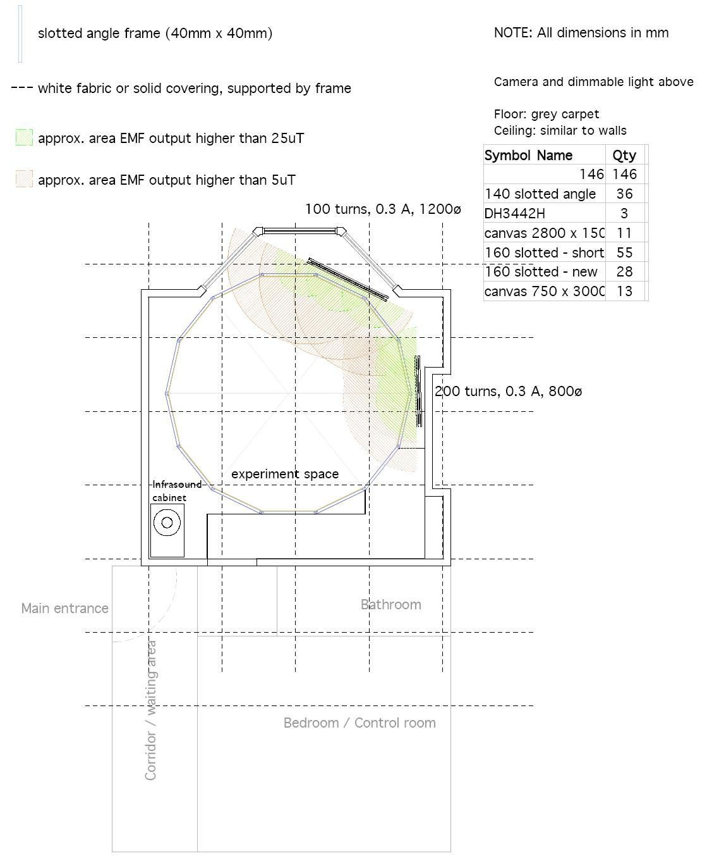
Figure 2

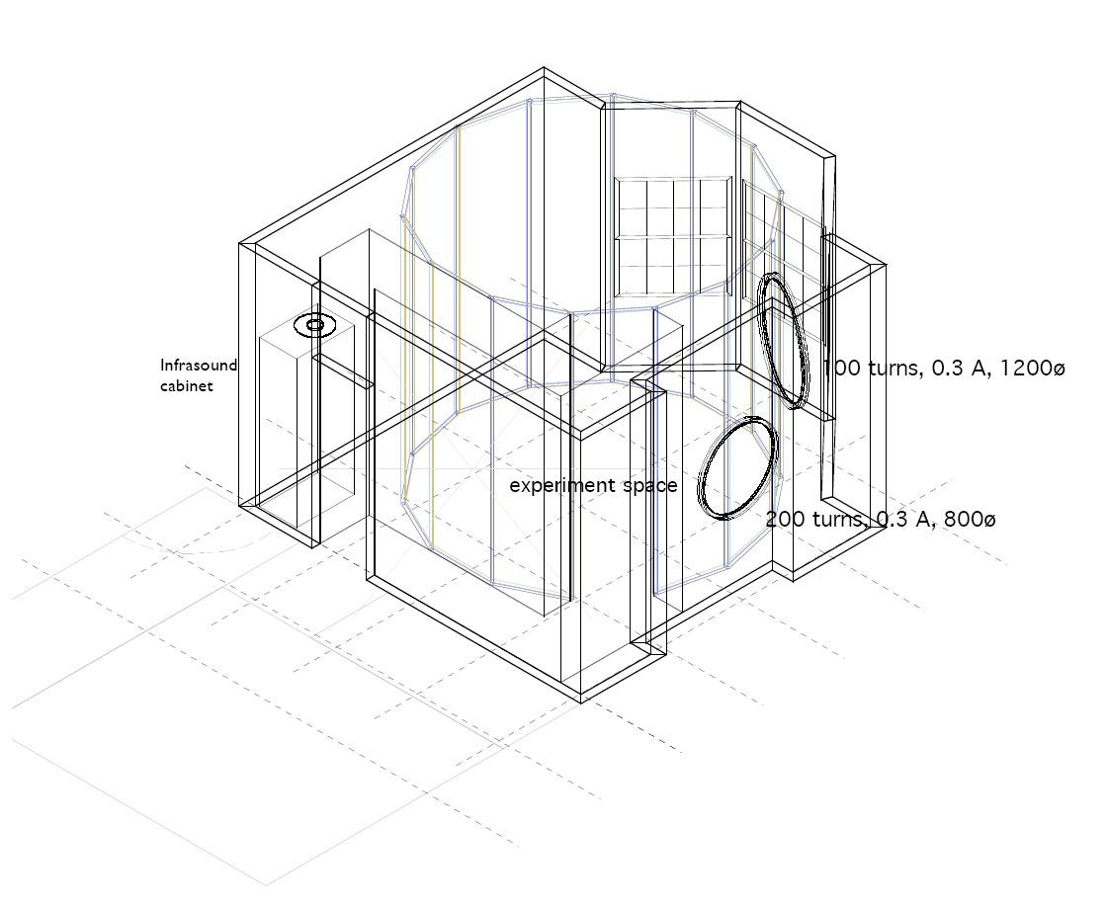

All analyses were also performed using the untransformed scores and the pattern of results produced was identical. Also, one referee felt that the format for the ASGS scale might be somewhat confusing for some participants because the “?” response option might just as well indicate uncertainty regarding the meaning of an item (e.g., “What does psychokinesis mean?”) as uncertainty regarding the ontological status of that particular paranormal claim (e.g., “I do not know if psychokinesis exists”). In line with this referee’s suggestion, additional analyses were carried out with the “?” responses recoded as “0”. Again, this made no difference to the pattern of effects found.

