Seeding Opportunity: How reappropriation of public space can catalyse sustainable behaviours
Duncan Fairfax, Tom White, Liam Hinshelwood, Rebecca Barnett
duncanfairfax@gmail.com

Abstract
Three years ago, in the former mill town of Todmorden, UK, a community group called Incredible Edible Todmorden (IET) was founded in response to the lack of Governmental engagement around the issues of environment, community and local economy. Using the universal language of food and re-appropriated public spaces as their medium IET are creating a strong participative culture within their community and in-turn building tacit sustainable behaviours.
In this paper designers from the Pi Studio housed at Goldsmiths, University of London speak of their engagement with IET in exploring how design can help facilitate the redirection of cultures, and moreover, why these cultures are so essential for our collective prosperity around the world. The paper also talks of the power of a positive material culture and its ability to convey often complex ideas in accessible ways.
Our findings have supported the idea that a critical form of design thinking, one that is reflective and that engages directly with communities (both with its people and its spaces) can collaboratively imagine and help redirect cultures. Its purpose is to create a “network of opportunity” for people to participate and engage with new and prosperous futures, forming the heart of community spaces.

KEYWORDS: UK, Incredible Edible Todmorden (IET), Environment, Community, Local Economy, Food, Pi Studio, Goldsmiths, Redirection, Tacit behaviours, Material Culture, Critical Design Thinking, People and Spaces, Participation

Introduction – A Beginning
Todmorden is a small, British market town sheltered amid the confluence of three valleys in the South Pennines. As with many towns in the north of England, its fortunes rose and fell with the industrial revolution as it swept through, and out of Britain. At the height of its prosperity Todmorden was home to over 30,000 residents, many benefiting from the reformist, co-operative and philanthropic movements that also rose and fell in response to the industrial revolution and whose origins are inexorably tied to the region. As the textile industry gradually emigrated for more profitable shores, Todmorden began to lose its identity. With its prosperity and population dwindling, deprivation crept through the town as crime and unemployment made their presence felt on the remaining 15,000 inhabitants. This is not a unique history; Todmorden’s story is archetypal of many British towns, particularly in the former industrial heartlands of the North and Midlands.
Today, weathered memories of thriving industry line the Halifax road as it tracks the Rochdale canal into Todmorden. The dereliction oddly compliments the rough beauty of the Calder Valley that has become the areas greatest asset, popular with commuters and tourists alike. Todmorden now acts as a commercial and cultural hub for outlying rural communities as well as a burgeoning tourist industry. Visitors are drawn by the town’s aesthetic charm captured in the architectural exuberance of the Town Hall and Unitarian Church, both monuments to the philanthropic excess of the 19th century. This charm is mirrored in the residents whose friendliness is only matched by their resolve, exemplified by Mary Clear and Pam Warhust, founders of Incredible Edible Todmorden (IET).
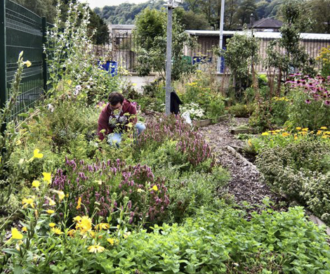
The seeds of IET took root in Clear and Warhurst’s frustration at the lack of leadership and action from government and industry not only on environmental issues but also on the future of the town. Using this frustration as fuel to take action where those who should were not, they sought to engage Todmorden in a scheme that could shift the behaviours of its inhabitants to lifestyles more able to sustain. Vital in achieving this was their choice of focus. Rather than tackling complex, divisive and often abstracted issues such as peak oil or climate change, Clear and Warhurst wanted a simple, tangible subject that could bring the, somewhat fractured, community together and prompt them to action. The ongoing success of IET can be attributed to the simplicity and astute recognition of the intrinsic values embedded within their chosen focus, food. It is through food that Clear and Warhurst plan to build greater self-sufficiency and resilience not only into the physical make up of the town, but into the mindsets of the inhabitants themselves.
Figure 1. Growing in Todmorden at the Apothecary Garden within the grounds of the Heathcare Center

The Language of Success
“Language can make or break a movement” – Pam Warhurst
Mankind’s instinctive, visceral understanding of food serves as a chink in the artifice of our established worldviews and becomes a “Trojan horse” as Warhurst puts it, through which larger issues can be addressed. Food is paramount to human beings. As Maslow’s scale indicates, food, along with the other physiological needs, forms the foundation upon which we build all else, indeed even our very sense of self (love and belonging, esteem, self-actualisation) and the fictions of our societal rules and institutions (safety). Communicating on this foundational level serves twin purposes. Firstly, we all share and understand the necessity to eat. For this reason food provides a common language that cuts through any demographic and as such it serves as a strong level on which to establish communal dialogue. A general and frequent criticism of environmental groups is their mainly white, mainly middleclass, mainly middle-aged uptake, essentially those who can ‘afford’ to care. From the outset IET intended to be inclusive and it is because of this focus on food and the accessibility of its language that they have been successful in engaging a broad demographic of the population. Dr Nick Green, IET’s chief grower, captures its simplicity and universality in their motto; “If you eat you’re in”.
Secondly, due to its axiomatic nature, food undermines many of those fictions we have constructed and live by and perhaps prompts us to question their validity. Food, in varying forms and quantities is paramount to ecology, the potential energy embodied in food is the fuel that facilitates all else, every expenditure, every interaction is inherently connected to this biological set of systems. This becomes a powerful means by which to gain a greater understanding of this ecology, the importance of preserving it and by proxy preserving ourselves. IET has shown that encouraging the urban growing of food has the potential to increase the ‘sustain-ability’ of communities, not only in relation to “recovering the vast numbers of pockets of agricultural land within the urban fabric" (Fry, 2009, p. 89); important if communities are going to continue to retain a level of food security, but also in making urban populations more capable of growing food. This has many benefits; locality, seasonality, nutritional value linked to freshness and increased understanding of the “connection between the care of the biophysical environment and care of self” (Fry, 2009, p. 88). Through a greater ability to understand and renegotiate our relationship with something as foundational as food and its systems, which have been warped by increasing commoditisation, it is likely that we will be more able to question that which threatens those systems. Furthermore, our interactions with food, specifically growing and cooking, constitute a praxis, which as Freire claims:
…enables people to overcome their false perception of reality. The world – no longer something to be described with deceptive words – becomes the object of that transforming action by men and women which results in their humanization. (Freire, 1998, p. 79)
As such food is much more than physical nutrition, it becomes the means by which IET aims to shift the prevailing, passive ontology the vast majority of us share towards an active and participatory ontology that has the ability to Future. It is this instinctive, visceral, or tacit relationship to food that seems to both transcend some of the most alienating and destructive aspects of our current world views that we, members of the Pi Studio, similarly saw as being possible ways to intervene in some of these larger issues in order to affect wider change.

Breaking the Rules for Change
“Do it until someone tells you to stop and then start a conversation” - Pam Warhurst
In the beginning IET employed a controversial method to become established within the town. Seeing opportunity within neglected, underused, or perhaps misused public and private spaces around Todmorden, Clear and Warhurst set about their campaign without any funding, consultation or permission. IET broke ground on a small, unloved and barely maintained patch of council owned grass beside a quiet road. Illegally, Clear and Warhurst renovated this redundant site, repurposing it to grow a small crop of vegetables and herbs that were left with an open invitation for Todmorden residents to help themselves. This first garden was soon joined by many more re-appropriated sites around the town, planted and tended by IET members but open for anyone to harvest. Illegal edible planting was soon appearing on unused public and private spaces; derelict land, parks, verges, supermarket car parks, even the local ‘In Bloom’ planters alongside the canal. Participants also opened up their front gardens to the community, freely sharing their own land with the town.
Due to this early, somewhat mischievous behaviour, IET are often labelled as ‘guerrilla gardeners’, this is an image they are quick to reject. IET’s continued, and very visible, incursion onto public spaces quickly brought them into direct conflict with the local council. This was a very deliberate plan; had IET approached the council seeking permission to grow on public land they would have likely been rejected or hamstrung by delays and restrictions. However their activities to that point had displayed the viability and popularity of the IET idea, something the council found hard to argue with. This conflict brought about a dialogue and now, for a nominal fee, residents of Todmorden can grow fruit and vegetables on council owned land throughout the town.
With this new legitimacy IET’s activities spread quickly into institutions. Now food is growing within schools, the local health centre, rail stations, care homes, churches and even into the grounds of the Police and Fire stations whose officers have developed a healthy rivalry over their sweetcorn yield. All of this planting could quickly be rejected as tokenistic given their limited quantity and low yields. However the food grown in and around the town serves primarily as a means to reconnect the inhabitants to the source of their food. Our agricultural and retail systems have bred deep ignorance as to how our food is grown or reared, presenting one of the most disturbing symptoms of the crisis. The primary purpose of these gardens is visibility; they bring the growing of food into the public sphere to educate and stimulate the population of the town into action. Recognising this, IET names these sites “Propaganda Gardens”. The propaganda gardens were not an overnight success. The notion that someone would contribute time and effort to grow food for anyone to pick was perhaps too contrary to accepted forms of exchange and so crops initially went unpicked. However, the idea soon caught on and as their popularity increased stories of contribution, reciprocity and kindness spread. Clear even found a bowl of fresh soup left on her doorstep made with vegetables from her front garden, which she had opened to the community. IET’s propaganda gardens are part of a simple strategy to build the towns resilience via three areas donned the “spinning plates”: learning, community and business.
Through several schemes IET are helping the population learn vital skills. The town’s schools are at the centre of this strategy; all of them now grow food on their grounds and have brought growing closer to the heart of their curriculums. However, learning is not just limited to children, IET run regular, free, cooking, growing and ‘Lost Arts’ workshops around the town for all ages. Key to the town’s resilience is the foundation of a strong economy. IET seeks to strengthen Todmorden’s local economy and keep the capital it holds circulating within. In order to do this IET have launched schemes to promote local producers, championed the town’s markets and helped to establish new local businesses. Todmorden is also benefiting from a new phenomenon, ‘vegetable tourism’. During the spring and summer, thanks to its growing reputation, tourists from all over the world have begun flocking to the town. IET offers these visitor’s tours of the many growing sites around the town, which conveniently end next to the market. By providing these opportunities to engage with each other, IET hopes to bring the community together and build the social capital needed to respond to the crises we are currently in, and those we will face in the future, including increased food insecurity and the impacts of climate change. Indeed as IET have helped bring the community together there have been some very tangible effects. Crime rates are down, local businesses are prospering (Southam, 2011), schools are improving (Arid, 2011) and the community is not only becoming more cohesive it is also growing more of its own food and learning why it is important to do so.
The opportunities that IET have created around learning, business and community, bound by the common language of food, are empowering Todmorden’s inhabitants to take greater ownership of their town and in so doing, greater ownership of the economic and environmental crises. Through the praxis of food they are no longer ‘victims’ passing the blame; instead they have become active participants in crises resolution. It would appear that as the community have re-appropriated their public spaces there seems to have been an ontological shift of the control over their mental spaces away from the consumerist norm; A positive example of the workings of Felix Guattari’s theory of the complex interdependence of what he describes as the “Three Ecologies of the Mental, the Social, and the Environmental”(Guattari, 1998). Spending time in Todmorden has made it clear that IET’s model is building a contributory and participative culture within the increasingly empowered and resilient community they have helped to re-establish.

Cross-Pollination - Design Meets Community
Design has long been responsible for shifting behaviour; design has an ontological and world shaping ability. As Anne-Marie Willis states, “We design our world, while our world acts back on us and designs us” (Willis, 2007). However designers’ use of this ability has been largely destructive under the parentage of consumerism. What design largely fails to recognise is that humans are conditioned beings (Arendt, 1959) therefore what is “designed” conditions us. Design, intentionally or not, has used this world shaping or ontologically formative quality to instigate a mode of being that is inherently unsustainable. It is within this context that we find ourselves today; there is a need for design to seek a greater critical engagement with audiences to shift behaviours into the service of a future rather than profits alone.
Recognising the impact of grassroots movements around the world designers from the Pi Studio sought to engage with this movement; to learn from their experience of shifting behaviour and gain a greater understanding of how redirective design could assist them in achieving this. Over the last year the Pi Studio has formed an ongoing relationship with IET on this basis. We are still early in this relationship and are finding ourselves in an unusual and challenging role that opens many questions. It is evident that IET, under the leadership of Clear and Warhurst, is successfully making a difference to the town. We felt that our engagement would not only provide a learning opportunity to us but that we would be able to offer something in return.
In the summer of 2010 IET brought together a diverse group of visiting experts along with local stakeholders to explore what they could do within the town to boost the local economy. The workshop resulted in a project to establish a “Green-Route” throughout the town that serves to draw focus onto local business by re-linking the two commercial areas of the town; currently divided by a busy arterial road. After making contact with IET and offering our services, Pi Studio was asked to contribute to the Green-Route project. We visited Todmorden once again to establish a brief. It was an opportunity to immerse ourselves in the critical requirements and questions of the Green-Route and to align ourselves with the discoveries made through the previous activities. Our purpose was to take the work of the previous insights and add to them, to build on the foundations of this work. In addition to this we had to help members of IET make the next ‘mental leap’ in the project, we felt they needed to be able to catch a glimpse of what the future of their town could entail; a vision of one possible future.
Having crafted a brief we spent the weeks ahead reflecting, discussing and ideating through the challenges and opportunities of this project. There were many difficult questions to mediate and many stake holders to consider throughout the process. This ongoing project is about fostering and nurturing positive behaviour in people to a tacit degree - to establish new ontologies; with the combined ambition to have a positive effect on the various ecologies of the town and eventually, nationally and internationally. It was essential for us to craft a vision of what this future could be, but without scaring people, our purpose here was to guide people not point fingers; – which invariably leads to defensive behaviour.
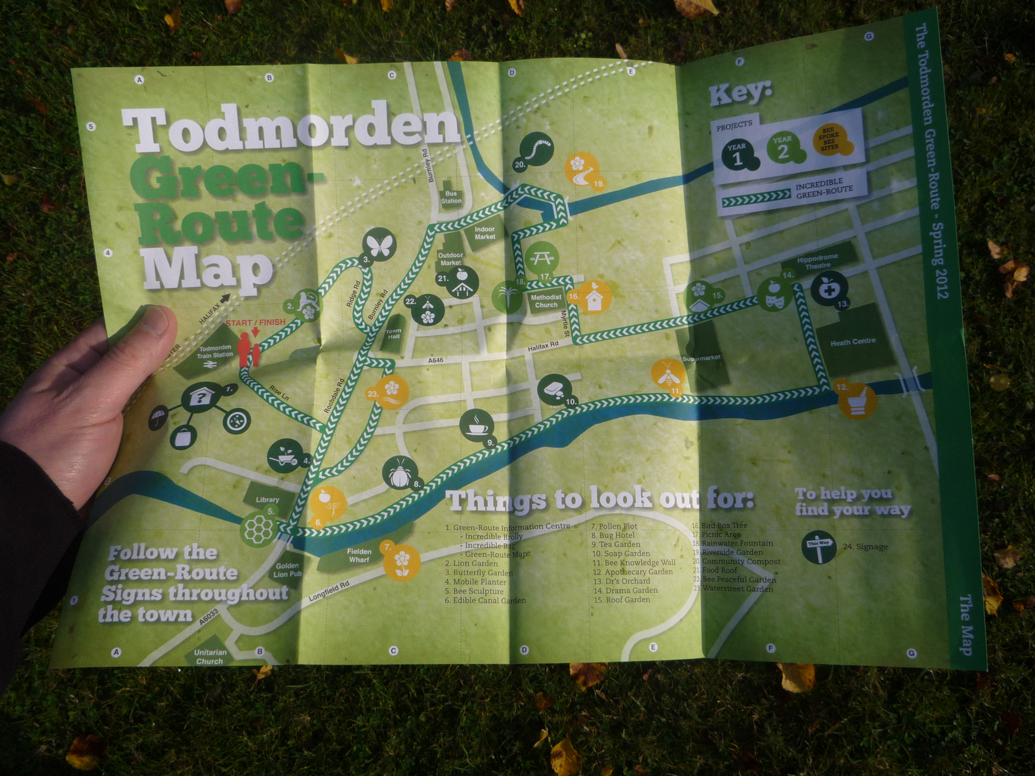
Our response took the form of an “ideas exhibition”. We presented a set of ideas together with content that helped to frame the concepts in a futural context. The ideas we created had to initiate a spiral effect of benefit on the town that would contribute to the “Three Plate Model”. We designed a range of responses that sat on a timeline of activity, from Incredible Institutes that would create curriculums of change throughout the UK and beyond, to “picking bags”, manufactured locally for sale to local people and visitors alike. This response proved to be extremely engaging for members of IET. It offered people a stake in the ground to use as a reference point going forward. It gave them opportunity to momentarily leave their preconceptions behind, to test their feelings about the route and the positive potential it could have on their community. People engaged in conversations in ways that had not previously taken place, debates emerged about what should and should not be developed further.
Figure 2 The Green Route Map

Following the success of this initial collaboration, the Pi Studio developed a second phase to the project. When exploring the notion of design in a community setting it is necessary from the outset to communicate the widespread value inherent in a positive form of material culture, and through this, highlight the problematic nature of mankind’s existing consumptive behaviours. Professor Tim Jackson has spoken extensively on the importance of material cultural. For millennia material artefacts have given mankind identity and have facilitated the well-being of our social groups. Our constructed, designed existence gives us identity, it gives us status - we construct meaning through objects. The way we clothe ourselves, the spaces in which dwell, the tools we use are of course all ways in which we maintain our survival from the elements, but further to this, they are props through which we communicate with the world, they are worlds within the world. Our material applications are symbolic, they signify all that is “us”; as Jackson describes:
…they (material commodities) signify our lives, loves, desires, successes and failings, both to others and ourselves…They derive their importance, in part at least, from their symbolic role in mediating and communicating personal, social and cultural meaning. (Jackson, 2005, p. 30)
We need only look back to the ritualistic practices of gift-giving or potlatch relationships amongst tribal groups and the material artefacts that were heavily integrated into these cultural traditions for confirmation. However, as history has unfolded, mankind has manufactured a fundamentally different materialistic paradigm through a powerful, yet homogenous economic system in which we experience first hand a culture that has spiralled alarmingly out of control, a culture that has become warped with novelty; as Jackson later describes, a culture in which “we can no longer distinguish between what matters and what glitters” (Jackson, 2009, p. 190). Or as Dreyfus & Kelly (2011) have also recently described it in their analysis of how we are finding meaning or value in a “post-secular” age, we are seduced by ‘All Things Shining’. However, it is crucial to point out that the emergent paradigm we have created for ourselves in recent history came from an ecologically appropriate ancestry. This isn’t to say that our ancestors were sustainably minded, what is being highlighted here is that materiality has remained as important throughout history as it is today. Without material existence we are lost, we would no longer posses the tools to support our personal and social existence. What has become corrupted is the context is the method in which material necessity is conveyed. The balance has tipped, profit has become the necessity of existence, not wellbeing. Therefore, in the pursuit of communicating these values in the hope of collaboratively creating solutions the Pi Studio developed a series of objects entitled “Fictional Futures”. We selected several concepts from our previous activity on the Green-Route and developed these into prototypes. In addition to this we designed a template for a methodology that would allow the town to implement its own strategy for identifying and labelling ‘local produce’.

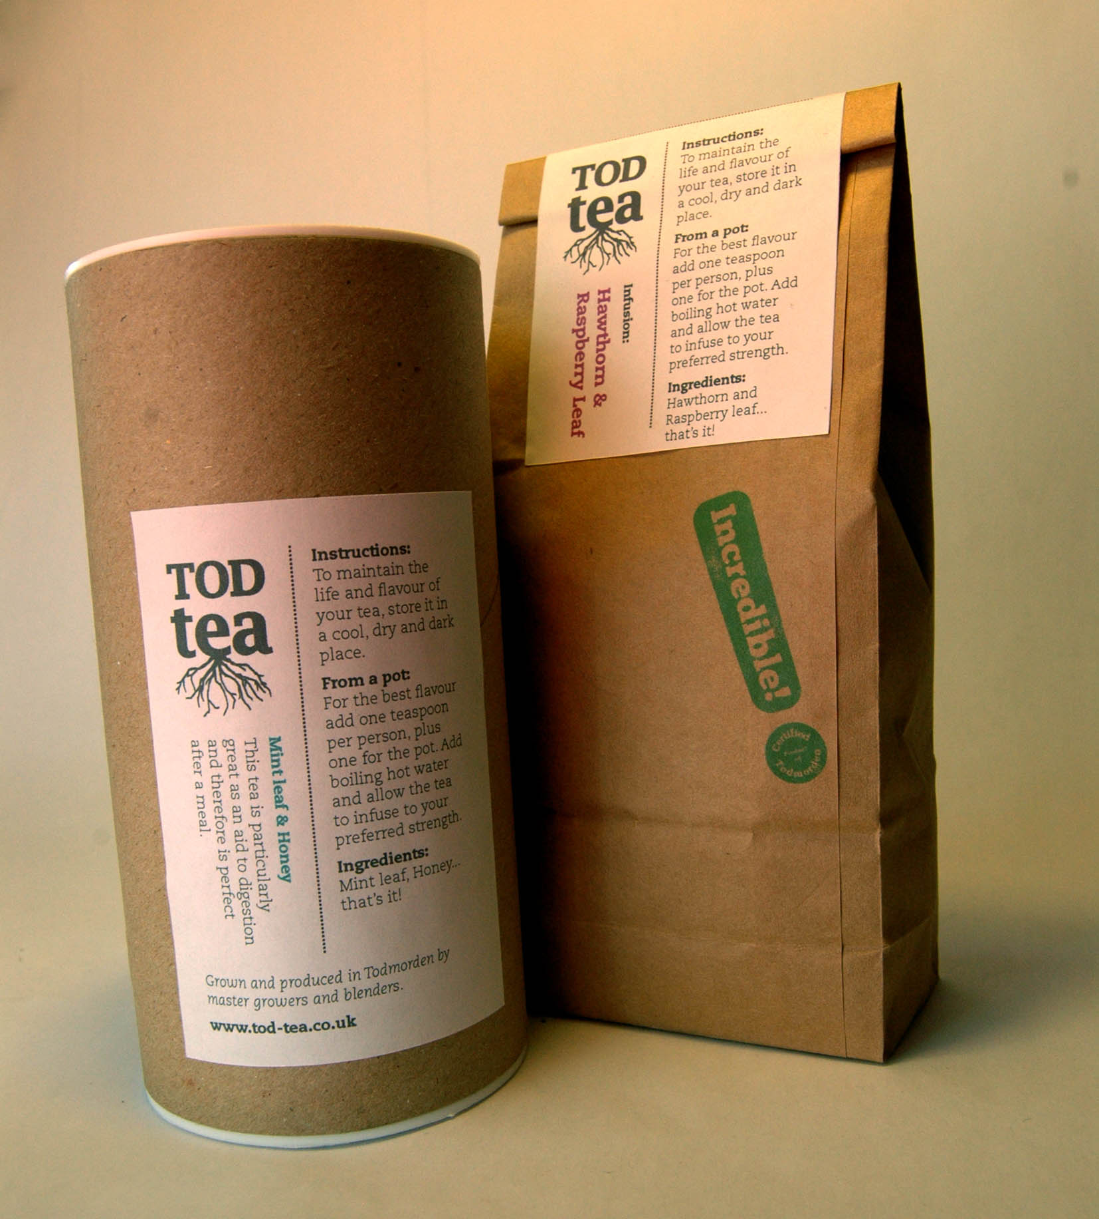
Figure 2 Tod Tea – a ‘prop’ offer a glimpse of a “Fictional Future” that is within reach of the IET community.
The motivation for selecting these objects specifically (a bar of soap, a jar of honey, a packet of tea, and a bag) as a context for development was two-fold. On one hand they can each be described as having a cultural importance, for example soap being a means of sanitising ourselves and tea having many social connotations, therefore these are objects we can describe as being “necessary” to our continued existence. On the other hand these are all objects and substances currently readily available to us in western society, however in contrast to this cultural familiarity they are each part of an evolutionary system that has (consciously or otherwise) worked to conceal its history, to disconnect the end user or consumer from the process by which these objects came to be. It is this abstracted process of ‘take, make, waste’ that conceals so many of the symptoms and scars of our material existence. Our intention through this work was not to simply disclose the network of these objects, to communicate or indeed ‘animate’ the screams of materials and nutrients being mechanically ripped from the ground and homogeneously injected into our lives; our intentions went further than this. Our purpose was to offer a glimpse of what was within reach of the IET community, these props would allow people to begin to understand the extent of the challenge, but also the fulfilment of what it would be like to genuinely partake in some of these projects and be part of the outcome, creating fictional products that could actually be held, passed around and discussed and thus also hopefully momentarily bring people into a different future.
The process we entered into when designing these products allowed us to dissect and re-imagine every aspect of the product’s life from start to finish. If we take tea as an example, we created a story that would communicate the current practices around tea production and consumption, in the story we described both the benefits and flaws amongst these practices. From here we identified many of the component parts that would be necessary to make a successful and ecologically “appropriate” product. A small network of people would have to be in place, land would be required to grow varieties of produce, space would be needed to dry and prepare blends, blends would have to be tried and tested, packaging and labelling would be necessary, printing and distribution. An entire network would need to be imagined to nurture this relatively small but important cultural practice.
This we feel, is the uniqueness of design in this context, it has the ability to prospect opportunity and research it thoroughly, but crucially it is able to link the missing pieces together and actually create a tangible output that can be tested and refined, before actually coming to life. Design becomes the facilitator of positive, redirective change.
These fictional products were established to begin developing a positive material culture within Todmorden, a culture that would communicate new and existing skills to all ages, a culture that would re-purpose and give new meaning to many of the growing sites throughout the community, a culture that may conceivably develop a viable economic output for those involved. In short, a culture that would spin all “Three Plates” of the IET model: Learning, Community and Business.
Our most recent feedback is that one of the ‘Fictional Futures’ projects has come to life, IET Soap is now available in stores around Todmorden, created from wild Sorrel seed and Yorkshire grit. The packaging on the soap comes complete with its very own “local produce” stamp.

Conclusion – The End of the Beginning
It is evident, through our work with Todmorden, that a critical form of design thinking and action, which engages directly with communities, can collaboratively begin to re-imagine and redirect cultures. In addition to this, many of the grassroots movements, such as IET hold lessons for design. Design should therefore seek to establish relationships with organizations such as these. Moreover, design needs to share the world shaping power of its discipline as well as the professional skills it encompasses to help amplify and spread its activities. Our experience confirms Alistair Faud-Luke’s assertion that designers should
…be prepared to take on multiple roles as non-aligned social brokers and catalysts, facilitators, authors, co-creators, co-designers and ‘happeners’ (i.e. making things actually happen). (Faud-Luke, 2009, p. 189)
As a team we have seen firsthand the benefit and potential in this practice.
Papanek (1985) famously claimed that: “All men are designers. All that we do, almost all the time is design, for design is basic to all humanity.” For too long design has been the domain purely of the professional and now needs to be reappropriated, in ways we are seeing hints of in Todmorden. Fundamentally this comes down to enabling, not pacifying, by designing projects and responses that seed opportunity for participation and contribution. We’ve witnessed an array of potential synergies for the ‘professional’ designer in this scenario. For example, designers are trained to tacitly question and challenge existing systems and perceived norms; design practice is a fantastic catalyst for revealing and prospecting opportunities to do things differently. Accomplished designers have the ability to ideate and communicate discourses through their practice. These are the skills and insights we should be attempting to collide with all aspects of society and particularly that of “Community”. However with these skills comes a need for recognition of the responsibility we must now adopt. It is naive to assume that we can continue to sit happily in the destructive mainstream of design when we have now the intellectual understanding of so many of the components of the collective crisis. What community groups and designers must now focus on is how to inspire uptake of the contributory values that will be so integral to our much needed ontological shift.

References
(Fry, T. (2009). Design Futuring: Sustainability, Ethics and New Practice. UNSW Press: Sydney
Freire, P. (1998). The Paulo Freire Reader. D New York: Continuum
Southam, H. (2011). The town that wants to feed itself. Geographical, December 2011. London
Aird, J. (2011) Incredible Edible Todmorden – Demonstrating our Impact. London: Esmee Fairbairn Foundation
Guattari, F. (1989). The Three Ecologies. New Formations, Number 8 Summer 1989. London
Willis, A M (Ed). (2007) Design Philosophy Papers, collection three. Team D/E/S Publications: Brisbane
Arendt, H. (1959). The Human Condition. The University of Chicago Press: Chicago
Jackson, T. (2005). Live Better by Consuming Less? Journal of Industrial Ecology, Vol 9, No. 1-2. Massachusetts Institute of Technology and Yale University
Jackson, T. (2009). Prosperity Without Growth, Economics for a finite planet. Earthscan: London
Dreyfuss, H. & Kelly, S D. (2011). All Things Shining: Reading the Western Classics to Find Meaning in a Secular Age. Free Press: Ney York
Fuad-Luke, A. (2009). Design Activism. Earthscan: London
Papanek, V. (1985). Design for the Real World. Academy Chicago. Chicago

